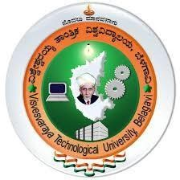

VISVESVARAYA TECHNOLOGICAL UNIVERSITY
Jnana Sangama, Belagavi, Karnataka

“AICTE Activity Point Programme”

Submitted in Partial Fulfillment for the Award of Degree of Bachelor of Engineering
in

CSE (ARTIFICIAL INTELLIGENCE AND MACHINE LEARNING)
Submitted by

Poojitha K D 4GW22CI032
Department AICTE Activity Faculty In-charge Ms. Jeevitha H M, Assistant Professor

AICTE Coordinator of the College
Dr. Thilagavathy R, Assistant Professor, Dept. of ECE

DEPARTMENT OF CSE (ARTIFICIAL INTELLIGENCE AND MACHINE LEARNING)

GSSS INSTITUTE OF ENGINEERING & TECHNOLOGY FOR WOMEN
Accredited by NAAC, New Delhi
Affiliated To Visvesvaraya Technological University, Belagavi Approved By All India Council for Technical Education, New Delhi
K.R.S Road Metagalli, Mysuru – 570016

2025-2026

Geetha Shishu Shikshana Sangha(R)

GSSS INSTITUTE OF ENGINEERING & TECHNOLOGY FOR WOMEN
K.R.S Road, Mysuru-570016, Karnataka
(Affiliated to VTU, Belagavi, Approved by AICTE -New Delhi & Govt. of Karnataka)

Accredited by NAAC, New Delhi

DEPARTMENT OF CSE (ARTIFICIAL INTELLIGENCE AND MACHINE LEARNING)

AICTE Activity Point Programme CERTIFICATE

This is to certify that the AICTE Activity Point Programme has been successfully carried out by Poojitha K D bearing usn 4GW22CI038, bonafide student of GSSSIETW in partial fulfillment of the requirements for the award of degree of CSE (Artificial Intelligence and Machine Learning) of Visvesvaraya Technological University, Belagavi during 2022-26. It is certified that all corrections, suggestions indicated for Internal Assessment have been incorporated in the report. The AICTE Activity Point Programme report has been approved as it satisfies the academic requirements in respect of AICTE Activity Point Programme for the said degree.

…………………………… Faculty In-charge Ms. Jeevitha H M
…………………………… Head of the Department Dr. Manjuprasad B


……………………………

Institute AICTE Activity Points Coordinator Dr. Thilagavathy R
……………………………

Principal
Dr. M. Shivakumar

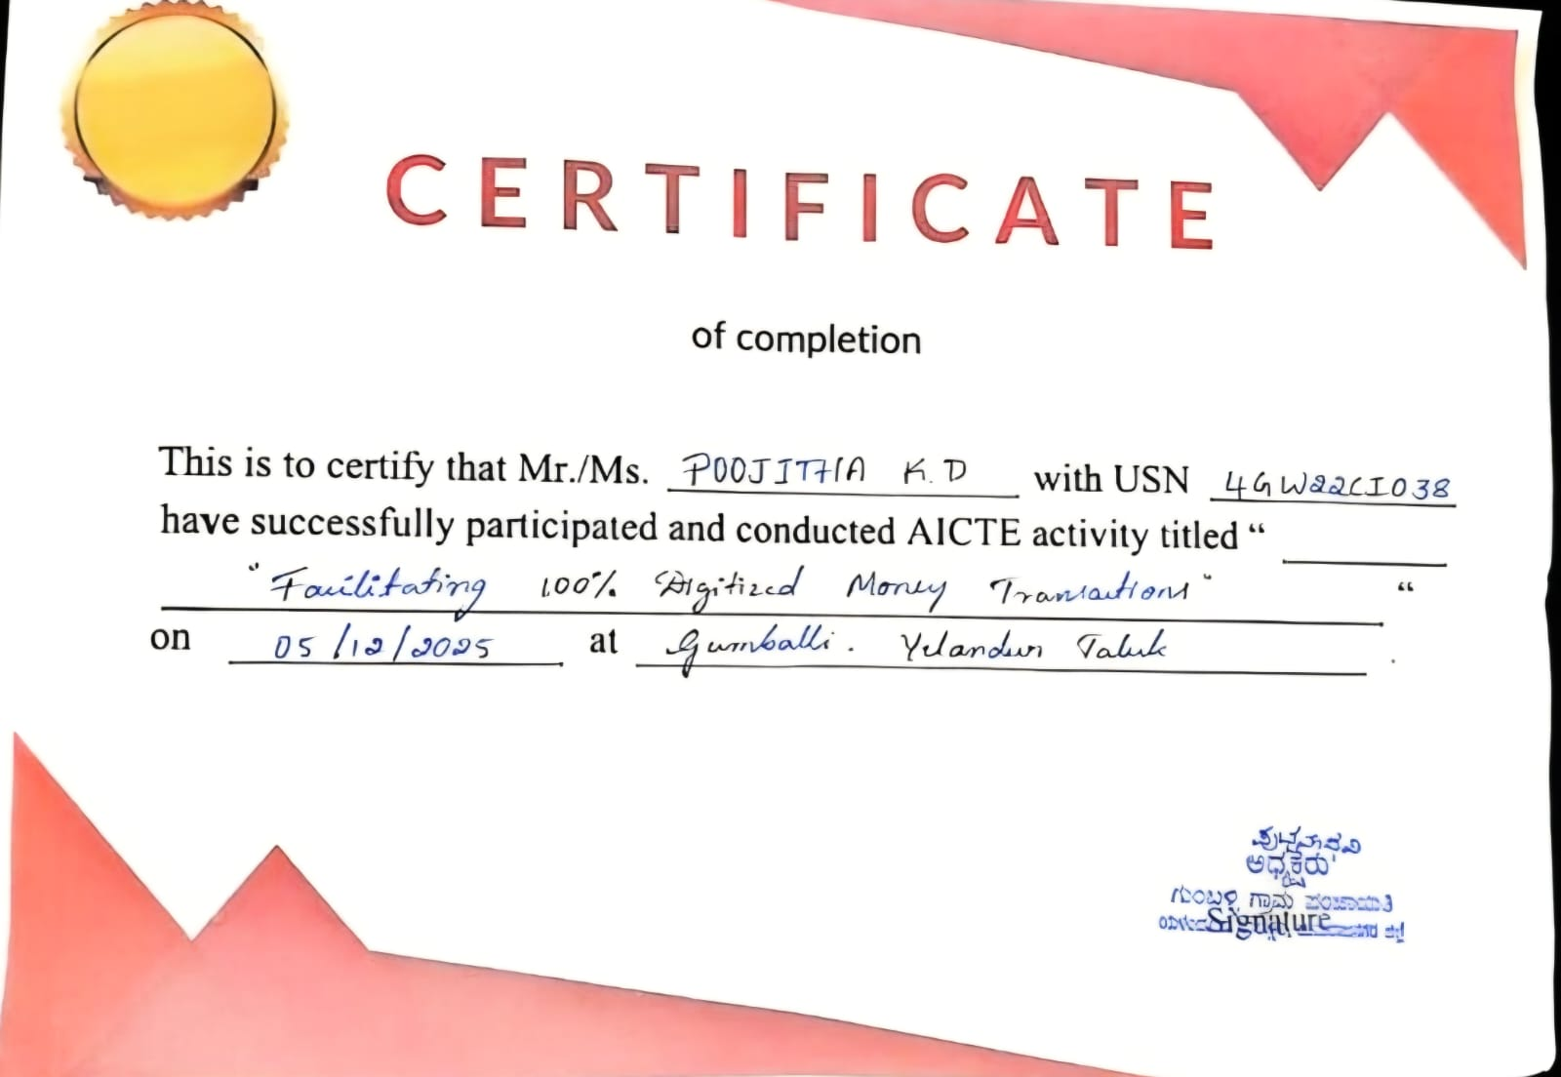
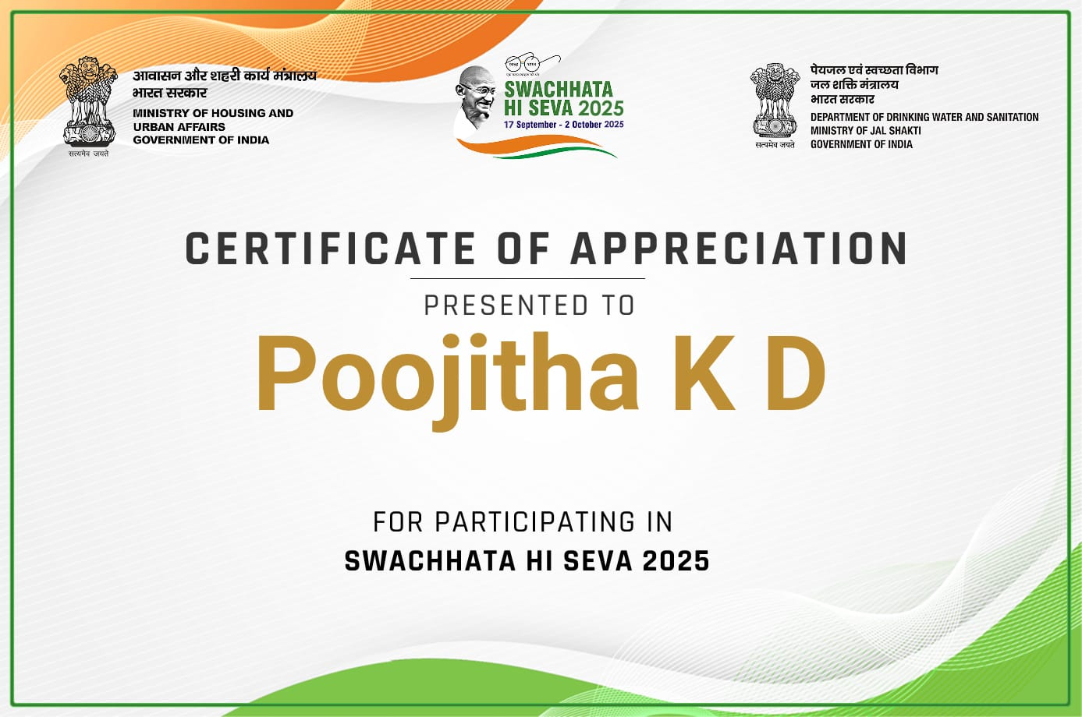


Geetha Shishu Shikshana Sangha(R)

GSSS INSTITUTE OF ENGINEERING & TECHNOLOGY FOR WOMEN
K.R.S Road, Mysuru- 570016, Karnataka
(Affiliated to VTU, Belagavi, Approved by AICTE -New Delhi & Govt. of Karnataka)

Accredited by NAAC, New Delhi
DEPARTMENT OF CSE (ARTIFICIAL INTELLIGENCE AND MACHINE LEARNING)

DECLARATION

I, Poojitha K D bearing the 4GW22CI038, student of Bachelor of Engineering, CSE (Artificial Intelligence and Machine Learning), GSSSIETW, Mysuru, hereby declare that the AICTE Activity Point Programme work has been carried out by me under the supervision and guidance of Department Staff Coordinators submitted by me as a partial fulfillment for the award of Bachelor of Engineering degree in CSE (Artificial Intelligence and Machine Learning) from Visvesvaraya Technological University, Belagavi during 2022-2026.

I hereby declared that the AICTE activity point work has been carried out at following partner organizations
- Swachhata Hi Seva Certificate
- Village Panchayt- Gumballi, Yelandur Taluk

………………………
Poojitha K D
4GW22CI038

ACKNOWLEDGEMENT
The joy and satisfaction that accompany the successful completion of any task would be incomplete without the mention of the people who made it possible.
First and foremost, I offer my sincere phrases of thanks to Late Smt. Vanaja B Pandit, Former Honorary Secretary, GSSS(R), Mysuru for the blessings and support.
I offer my sincere phrases of thanks to Smt. Anupama B Pandit, Secretary, GSSS(R), and the Management of GSSSIETW, Mysuru for providing help and support to carry out the AICTE Activity programme.
I would like to express my gratitude to our Principal, Dr. Shivakumar M for providing us a congenial environment for engineering studies and also for having showed us the way to carry out the AICTE Activity programme.
I would like to thank Dr. Thilagavathy R, Assistant Professor and AICTE Activity Points Coordinator, Department of Electronics & Communication Engineering for guidance & motivation throughout the tenure of this AICTE Activity Point Programme.
I consider it is a privilege and honour to express my sincere grateful to our HoD & Guide Dr. Manjuprasad B, Professor and Head of the Department of CSE (Artificial Intelligence & Machine Learning) for his support and invaluable guidance, motivation & encouragement throughout the tenure of this societal project.
I would like to thank our Department AICTE Coordinator Ms. Jeevitha H M, Assistant Professor, Department of CSE (Artificial Intelligence & Machine Learning) for her support, guidance, motivation, encouragement for the successful completion of this Societal project.
I would also like to sincerely acknowledge my friends teammates for their support throughout the activities, including travelling together, teamwork during field visits, and coordination in organizing travel arrangements, which contributed to the smooth execution of the programme

Sl. No. | Activity Category No. and Title | From date-To date | Number of Week | Total No of Hours | Points earned
1 | A4 Tourism Promotion Innovative Approaches | 25/05/2023–  05/07/2023 | 2 | 90 | 20
2 | A8 Facilitating 100% Digitized money transactions | 15/02/2025–  02/03/2025 | 2 | 80 | 20
3 | A3 Developing Sustainable Water Management system | 26/10/2024–  11/11/2024 | 2 | 80 | 20
4 | A14 Spreading public awareness under rural outreach programmes | 06/01/2024–  07/02/2024 | 2 | 80 | 20
5 | A15 Contribution to any national level initiative of Government of India. For e.g. Digital India/ Skill India/ Swachh Bharat Internship etc., | 14/11/2023–  03/12/2023 | 2 | 80 | 20
TOTAL ACTIVITY POINTS EARNED |  |  | 100

I hereby declared that the AICTE activity point work has been carried out at following location
.
- Mysore
- Srirangapatna

Signature of the Guide

The AICTE initiative I participated in became one of the most significant learning experiences of my academic journey. It provided an opportunity to move beyond theoretical knowledge and engage in practical, real-world exploration. As part of this activity, I studied various tourist destinations across Mysuru to understand their historical, cultural, spiritual, and environmental significance. This hands-on exposure helped me realize how tourism contributes to regional development while also preserving local traditions and heritage.

During the activity, I explored multiple categories of tourism, including heritage, spiritual, educational, eco-tourism, natural, and cultural sites. By visiting diverse locations, I observed architectural designs, maintenance practices, visitor facilities, and overall tourism management. This enabled me to understand how different destinations are organized and how tourism authorities maintain these sites to ensure a positive experience for visitors.

The experience highlighted the importance of preserving historical monuments, maintaining public spaces, and promoting responsible tourism practices. I gained insights into how tourism generates employment opportunities, supports local communities, and enhances cultural awareness among visitors. Additionally, I understood the role of sustainable practices in protecting both natural ecosystems and cultural heritage for future generations.

Overall, this activity contributed significantly to my personal and academic growth. It enhanced my observational skills, improved my communication abilities, and provided a deeper understanding of how tourism functions in real-life scenarios. The experience also motivated me to become a more responsible individual who contributes positively to society and supports sustainable development initiatives.

TABLE OF CONTENTS

Chapter/Activity Title
Chapter 1 Introduction

Chapter 2 Activities
Activity 1 Tourism Promotion Through Digital Documentation
  - Overview
  - Use of Technology
  - Sustainable Development best practices

Activity 2 Facilitating 100% Digitized Money Transactions (UPI Awareness)
  - Overview
  - Use of Technology
  - Sustainable Development best practices

Activity 3 Developing Sustainable Water Management system
  - Overview
  - Use of Technology
  - Sustainable Development best practices

Activity 4 Spreading Public Awareness under Rural Outreach
Programmes – Paper Bag
  - Overview
  - Use of Technology
  - Sustainable Development best practices

Activity 5 Contribution to any national level initiative of Government of India - Swachh Bharat Internship
  - Overview
  - Use of Technology
  - Sustainable Development best practices

Chapter 3 Overall Learning
  - Innovative approaches taken
  - Research done
  - Knowledge and understanding gained
  - Professional values and best practices incorporated
  - Areas for further development
  - Challenges and solutions
  - Feedback and continuous improvement

Chapter 4 Documentation of Activities

Chapter 5 Conclusion

INTRODUCTION
The current education system focuses not only on academic performance but also on the ability of students to apply their knowledge in real-life situations and fulfill their social responsibilities. The AICTE Activity Program plays an important role in achieving this by providing students with opportunities to gain practical exposure through community-based activities. This report presents the work carried out and the experiences gained through participation in these activities.
As part of this program, I was involved in a range of activities that focused on social awareness, environmental responsibility, and community development. These activities provided an opportunity to interact with people from different backgrounds and understand real-world challenges.
Through these experiences, I was able to apply my academic knowledge in practical situations and contribute meaningfully to society. It also helped me understand how real-life problems require simple and practical solutions rather than theoretical knowledge alone.
The activities also highlighted the importance of sustainable practices, cleanliness, digital awareness, and support for local communities. I observed how small efforts and awareness can influence people’s behavior and bring positive changes in society.
In addition to practical knowledge, these activities helped in developing essential skills such as communication, problem-solving, and adaptability. Interacting with different people improved my confidence and ability to handle real-world situations.
Overall, the AICTE Activity Program provided a valuable learning experience beyond the classroom. It emphasized the importance of combining knowledge with action and encouraged a sense of responsibility towards society and the environment.
.

CHAPTER 2

ACTIVITY – 1

TOURISM PROMOTION INNOVATIVE APPROACHES
Activity Details:

DATE | ACTIVITY HEAD | DAYS
25/05/2023-  05/07/2023 | 4. Tourism promotion innovative  approaches | 14

Aim:

To promote tourism by visiting important places and understanding their cultural, historical, and educational value, while exploring simple ways to improve visitor awareness and experience.

Objective:

To study and understand the importance of different tourist places such as temples, museums and heritage sites, and to create awareness about their maintenance and promotion. It also aims to observe how these places attract visitors and how tourism can be improved in a practical way.

Procedure:

The activity was carried out by visiting different places such as Mysore Zoo, Lalit Mahal Palace, Srirangapatna Vishnu Temple, Ranganatha Swamy Temple, Mysore Palace, Srirangapatna Water Gate, St. Philomena's Church, Sri Lakshmi Narayan Swamy Temple, Chamundi Hills, Mysore Colonial Barley Dungeon, and Tipu Sultan Fort on different days. When I went to these places I looked at the surroundings and the facilities they had. I also checked how clean the places were and how visitors were interacting with each other. At each place I found out about its history and importance. I got this information from the boards I read, the guides I talked to and from looking around. I also talked to the visitors and they told me about their experiences and suggestions. From what I saw I thought of ways to improve tourism like keeping places clean and having clear information boards. Going to these places helped me understand why it is important to take care of them and to promote tourism without causing harm. The activity was helpful in understanding the importance of these places and how I can help people visit them without causing any damage.

Overview:
The AICTE community engagement activities required me to implement a Tourism Promotion project. The main aim was to understand the importance of tourist places. The activity involved visiting locations including Mysore Zoo, Lalit Mahal Palace, Srirangapatna Ranganatha Swamy Temple, Mysore Palace, Srirangapatna Water Gate, St. Philomena's Church, Sri Lakshmi Narayan Swamy Temple, Chamundi Hills, Mysore Colonial Barley Dungeon, and Tipu Sultan Fort, as each site offered cultural and educational value.
I used these locations as study sites to observe how visitors interacted with the surroundings and utilized the available facilities. I learned about the background and importance of these places through available information sources and direct observation. Based on my visits, I developed simple ideas to improve tourism, such as better maintenance, clearer guidance for visitors, and increased awareness about preservation.
The activity provided me with insights about tourism's vital function in society and how even minor practices can assist in conservation and site maintenance. The experience fostered in me a deeper understanding of our duty to safeguard both cultural assets and shared community environments.

Use of Technology:
Technology was used to support the activity in a simple and effective way. Mobile phones were used to capture photos and basic information during the visits to different places. Google Maps was used to locate the places and plan the travel routes efficiently.
Online sources were referred to for collecting basic details about each location and understanding their importance. This use of technology helped me gather information easily and made the activity more organized and informative.

Sustainable Development best Practices:

The aim of my work was to explore responsible tourism practices which I tested at our research sites. I promoted cleanliness through their efforts to prevent littering and preserve both public areas and heritage sites. I established awareness of the need to protect these locations through basic visitor guidelines.

I realized that local community support is essential for maintaining these sites which will be accessible to future tourists. I shared basic waste disposal methods and safe public space usage during their fieldwork activities.
The activities support sustainable development because they work to protect both cultural heritage and natural environmental assets. The activity helped us discover how tourism operations can maintain site value through responsible practices.

ACTIVITY – 2

FACILITATING 100% DIGITIZED MONEY TRANSACTIONS
Activity Details:

DATE | ACTIVITY HEAD | DAYS
15/02/2025-  02/03/2025 | 8. Facilitating 100% digitized money  transaction | 10

Aim:

To promote and support the use of 100% digitized money transactions among people, encouraging them to use digital payment methods for easy and secure transactions.

Objective:

To create awareness about digital payment systems and help people understand their usage, reducing the use of cash and improving digital knowledge in the community.

Procedure:

The activity was carried out by interacting with local people and small vendors in different areas. I explained the importance and benefits of digital payment methods such as UPI and other online transactions. Basic guidance was given on how to use these payment options in a safe and simple way. People were encouraged to adopt digital transactions for their daily use. Through this activity, I helped in spreading awareness about digital payments and supported the idea of a cashless and digitally connected society.

Overview:
I executed an awareness campaign to educate local residents and small vendors about 100% digital money transactions which Digital India programs. The main objective was to educate them about the use of digital payment methods such as UPI and other online transaction platforms for safe and easy payments. Demonstrated how digital payment systems enable users to save time while they make secure payments without needing to handle cash.

I showed vendors and residents how to complete digital payments while I answered their questions about system security and payment methods. The project enabled people to learn about digital transactions which helped create a community that uses electronic payments and maintains digital connections.

Use of Technology:
Technology played an important role in this activity. Smartphones were used to explain and demonstrate how digital payments work in a simple way. Basic features like sending money, receiving payments, and checking transactions were shown during the interaction.
Internet and mobile payment options were used to make the explanation clear and easy to understand. This helped people learn practically and made the activity more effective and interactive.

Sustainable Development best Practices:
The activity promoted sustainable methods because it encouraged people to use digital payments rather than cash transactions. The practice of using less paper money results in resource conservation while establishing an environmentally friendly business model. The system enables users to complete their financial interactions with better speed and operational effectiveness.
Digital payment systems deliver two main advantages which include enhanced financial transparency and decreased requirements for physical cash management. People improve their financial management skills through this solution. The project created public awareness about the secure and responsible usage of digital systems.
The initiative promotes sustainable development through its dual objectives of enhancing digital literacy and assisting individuals in adopting contemporary efficient methods for their routine financial activities.

ACTIVITY – 3

DEVELOPING SUSTAINABLE WATER MANAGEMENT SYSTEM
Activity Details:

DATE | ACTIVITY HEAD | DAYS
26/10/2024-  11/11/2024 | 3. Developing Sustainable Water Management system | 10

Aim:

The aim of this activity was to understand how wastewater is scientifically treated, recycled, and reused in a decentralized Sewage Treatment Plant (STP). By visiting the Krishna Water Solutions in Bangalore, I aimed to gain practical knowledge about sustainable water management practices that help reduce freshwater usage and promote environmentally responsible living within urban residential communities.

Objective:

The objective of this activity was to study the complete functioning of an STP, observe the stepby-step treatment process, and understand how treated water is reused for gardening and flushing purposes. This activity also aimed to create awareness about the importance of wastewater recycling, reducing groundwater extraction, and supporting sustainable development in apartment complexes

Procedure:

The activity began with my visit to the STP unit at Bangalore, where the technician explained the overall wastewater treatment process. I first observed the screening chamber where large solid waste was removed. Then I visited the aeration tank where blowers supplied oxygen to support bacterial breakdown of organic matter. Next, I saw the clarifier where sludge settled and partially treated water separated. The water then passed through tertiary treatment, which included sand and carbon filtration followed by disinfection. I also learned how the collected sludge was dried and used as manure. Finally, I observed how the fully treated water was stored separately and reused for gardening and toilet flushing within the apartment premises.

Overview:
This activity provided a thorough understanding of how sustainable water management can be effectively practiced in residential communities. The visit to the Krishna Water Solution STP showed how wastewater can be purified through multiple stages and reused safely for non-drinking purposes. The system not only reduces the demand on freshwater sources but also prevents pollution by ensuring that untreated wastewater does not enter the environment. Through this activity, I gained awareness of the importance of adopting efficient water conservation systems, especially in growing urban areas where water scarcity is becoming a major concern.

Use of Technology:
Technology played an essential role throughout the wastewater treatment process. Automated pumps, aeration blowers, and filtration units ensured continuous flow and effective treatment. Sensors and digital meters were used to monitor water quality parameters such as turbidity, pH, and dissolved oxygen. Control panels helped regulate the operation of different units with minimal manual intervention. These technological components improved efficiency, ensured consistent output quality, and made the overall system more reliable and sustainable.

Sustainable Development best Practices:

The STP followed several sustainable practices that helped conserve water and protect the environment. Treated wastewater was reused for gardening and toilet flushing, reducing the need for fresh groundwater. The dried sludge from the clarifier was converted into organic manure, supporting waste-to-resource recycling. The multi-stage filtration and disinfection process ensured safe and eco-friendly water reuse. Overall, the system helped reduce pollution, save water, and promote responsible resource management within the apartment community.

.

ACTIVITY – 4

SPREADING PUBLIC AWARENESS UNDER RURAL OUTREACH PROGRAMMES
Activity Details:

DATE | ACTIVITY HEAD | DAYS
06/01/2024-  04/02/2024 | 14. Spreading Public Awareness under  Rural Outreach Programmes | 10

Aim:

To spread public awareness about reducing plastic usage and promoting eco-friendly alternatives like paper bags under rural outreach programmes.

Objective:

To educate local people and small vendors about the harmful effects of plastic on the environment and encourage the use of paper bags for daily purposes.

Procedure:

The program executed several activities through its rural outreach work in various locations. I visited local shopping areas and public spaces to interact with residents and vendors for the purpose of demonstrating plastic usage dangers. The project created understanding about paper bags which serve as environmentally sustainable substitutes. The program motivated people to decrease their plastic consumption while they practiced basic eco-friendly habits throughout their daily activities. The activity helped in spreading awareness and promoting a cleaner and healthier environment.

Overview:
The Rural Outreach Programme included an awareness activity which I conducted to educate people about plastic reduction methods and sustainable eco-friendly practices. I traveled to various locations to educate local residents and shop owners about plastic pollution and the benefits of paper bag usage.

The activity demonstrated how we can protect the environment by replacing plastic bags with paper bags. People were encouraged to implement simple modifications in their daily activities. The initiative successfully raised public awareness while promoting sustainable environmental practices.

Use of Technology:

Technology was used to support the awareness activity in a simple way. Mobile devices were used to capture photos of the outreach work and the interactions with people. These helped in documenting the activity and understanding its impact.
Basic online sources were also referred to for understanding simple methods and ideas related to eco-friendly practices. The use of technology helped in making the activity more organized and effective.

Sustainable Development best Practices:
The activity achieved its sustainability goal through its promotion of paper bag usage as an alternative to single-use plastic products. The process of reducing plastic consumption works to safeguard natural ecosystems while decreasing pollutant levels. The solution enables people to implement sustainable practices through the use of environmentally safe biodegradable products in their everyday activities.
The local population together with market vendors established resource management practices through their direct interaction with each other. The environment needed to be cleaned through minor environmental improvements which included switching from plastic materials to paper bags.
The activity demonstrated that basic activities enable people to save resources while they practice environmentally friendly habits throughout their community.

ACTIVITY – 5

CONTRIBUTION TO ANY NATIONAL LEVEL INITIATIVE OF GOVERNMENT OF INDIA
Activity Details:

DATE | ACTIVITY HEAD | DAYS
14/11/2023-  03/12/2023 | 15.Contribution to any national level initiative of Government of India | 10

Aim:

To promote cleanliness, hygiene, and environmental responsibility among the public as part of the Swachh Bharat , and encourage people to adopt sustainable waste management practices.

Objective:

To create awareness about the importance of cleanliness, proper waste disposal, and hygiene, while motivating individuals to actively participate in maintaining a clean and healthy environment.

Procedure:

The activity was carried out by visiting a local area such as a street, public place, or community zone. Students actively participated in cleaning the surroundings by collecting waste materials and segregating them into biodegradable and non-biodegradable categories. Awareness was created among the public about the harmful effects of improper waste disposal and the importance of maintaining hygiene. People were encouraged to avoid plastic usage and adopt eco-friendly alternatives like cloth and paper bags. Interaction sessions were conducted to explain simple cleanliness practices that can be followed in daily life.

Overview:
This activity was conducted to promote cleanliness and environmental awareness among the public. The main aim was to encourage people to maintain clean surroundings and adopt hygienic practices in their daily lives.

Through active participation and interaction, the initiative helped people understand the importance of sanitation and waste management. The activity demonstrated how individual responsibility and community effort can contribute to a cleaner and healthier environment.

Use of Technology:

Technology was used in a simple and effective way to support the activity. Mobile phones were used to capture photos and videos for documentation. Online resources were referred to understand waste management practices and awareness methods. Social media platforms were used to spread awareness about cleanliness and the importance of maintaining hygienic surroundings. This helped in reaching a wider audience and promoting the message effectively.

Sustainable Development best Practices:
The activity supported sustainable development by promoting cleanliness, proper waste management, and reduction of plastic usage. It encouraged people to adopt eco-friendly practices such as using reusable bags and segregating waste. The initiative contributed to building awareness about environmental protection and public health. It highlighted the importance of collective responsibility in maintaining cleanliness and ensuring a sustainable future.

CHAPTER 3

OVERALL LEARNING

Innovative Approaches Taken
    - The tourism promotion activity involved visiting different places and identifying simple ways to improve visitor awareness and experience.
    - I demonstrated to people how to use online payment methods through Digital Money Transactions by providing them with step-by-step instructions.
    - The water management activity focused learning how the water is treated to reuse it.
    - We conducted outreach events in rural areas to show people how to protect the environment through paper bag usage instead of plastic bags.
    - We promoted cleanliness, hygiene, and environmental responsibility among the public as part of the Swachh Bharat

Research Done

    - Before each activity, basic information was collected to understand the topic and perform the tasks effectively.
    - The tourism activity helped us learn about the cultural, historical, and environmental importance of different locations.
    - The digital payments activity provided knowledge about UPI, online transactions, and safe usage of digital systems.
    - The water management activity helped us understand how wastewater is scientifically treated, recycled, and reused
    - The Swachh Bharat Internship helped us to encourage people to adopt sustainable waste management practices.

Knowledge and Understanding Gained
    - These activities improved my understanding of social responsibility, teamwork, and communication skills.
    - The digital payments activity showed me how people use technology for their everyday transactions and the advantages it brings.
    - Through tourism promotion I learned about the value of various locations and their cultural heritage and social significance.
    - I learned about environmental protection and plastic waste reduction through my experience with rural outreach programs.

Professional Values and Best Practices Incorporated
    - The activities taught me how to work as part of a team while developing my ability to communicate and my capacity to handle work tasks.
    - The activities helped me develop values which included discipline and honesty and cooperation and social awareness.
    - The organization practiced proper environmental procedures through its commitment to maintaining cleanliness and using sustainable practices and educating the public.
    - The activities helped participants develop fundamental digital skills together with basic abilities to solve problems.

Areas for Further Development

    - Cleanliness activities will see improvement through enhanced focus on waste segregation and proper disposal methods.
    - Digital awareness can be extended to more people, especially those who are not familiar with online payments.
    - The provision of better visitor information and guidance services will enhance tourism promotion efforts.

    - Rural awareness activities will benefit from additional interactive elements and practical demonstrations which help people achieve better understanding.

3.5 Challenges and Solutions
- Some challenges faced included less interest from people during awareness activities, hesitation in using digital payments, and limited time.
- These were managed by explaining things in a simple way, giving basic demonstrations, and interacting patiently with people.
- Other issues like weather and limited resources were handled through teamwork and proper planning.

3.7 Feedback and Continuous Improvement

- The feedback received from teachers and others showed positive results which created an encouraging atmosphere.
- The experience developed my confidence while I learned to communicate and work together with others.
- This activity inspired me to contribute towards helping society by applying my knowledge and skills for the betterment of the community.
- I will participate in similar activities because I want to improve my skills through practical experience in the future.

CHAPTER 4
DOCUMENTATION OF ACTIVITIES

Activity 1: Tourism Promotion – Innovative Approaches

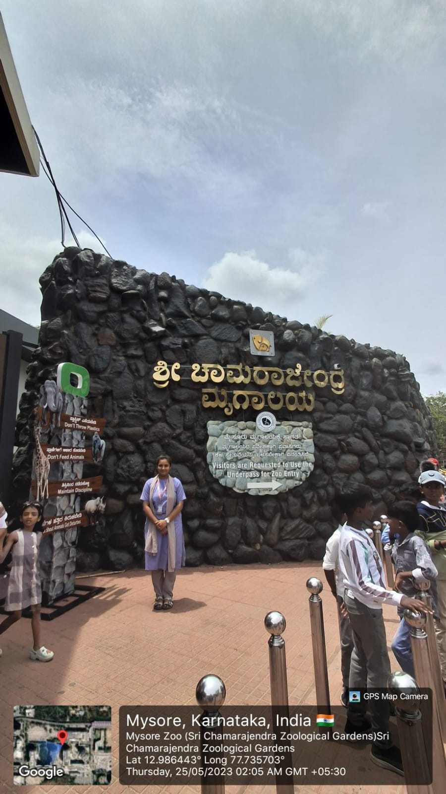
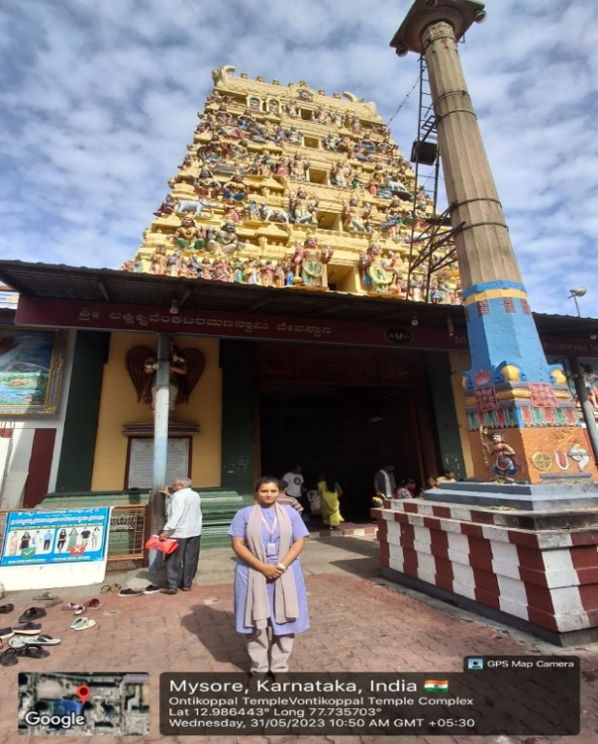

Figure 1.1 Sri Chamarajendra Zoological Gardens Figure 1.2 Ontikoppal Temple
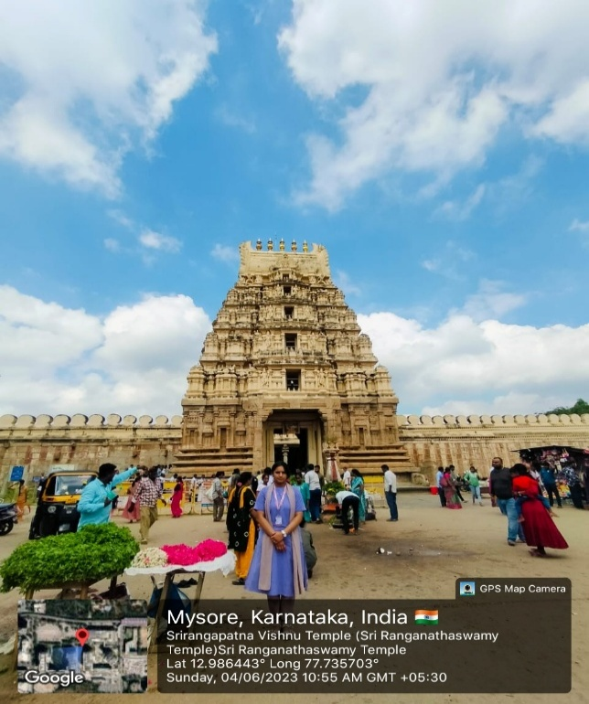
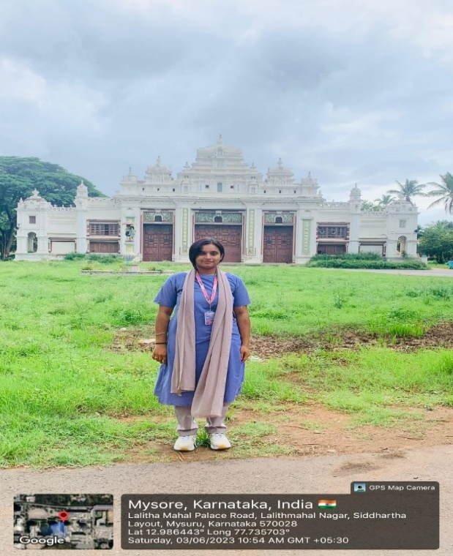

Figure 1.3 Lalitha Mahal Palace Figure 1.4 Sri Ranganatha Swamy Temple

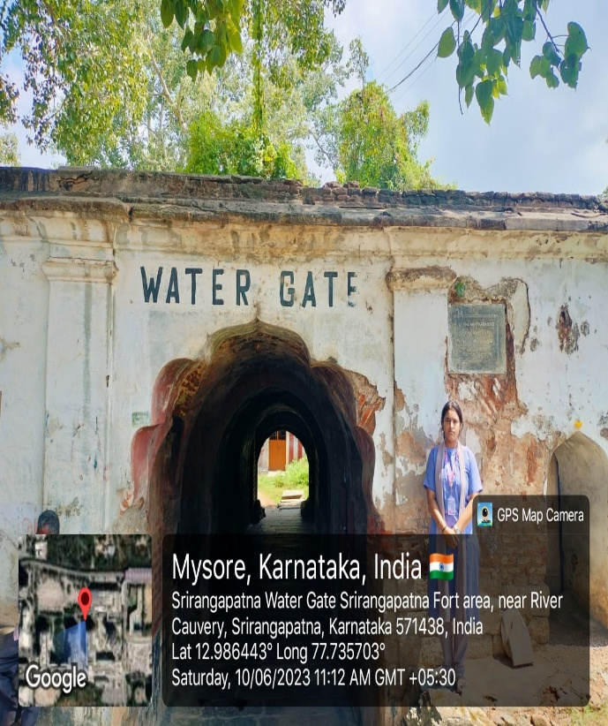
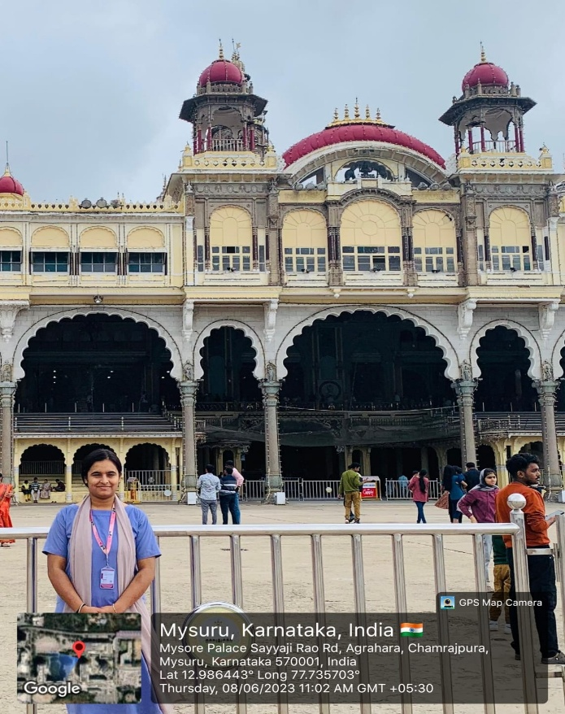

Figure 1.5 Mysuru Palace Figure 1.6 Srirangapatna Water Gate

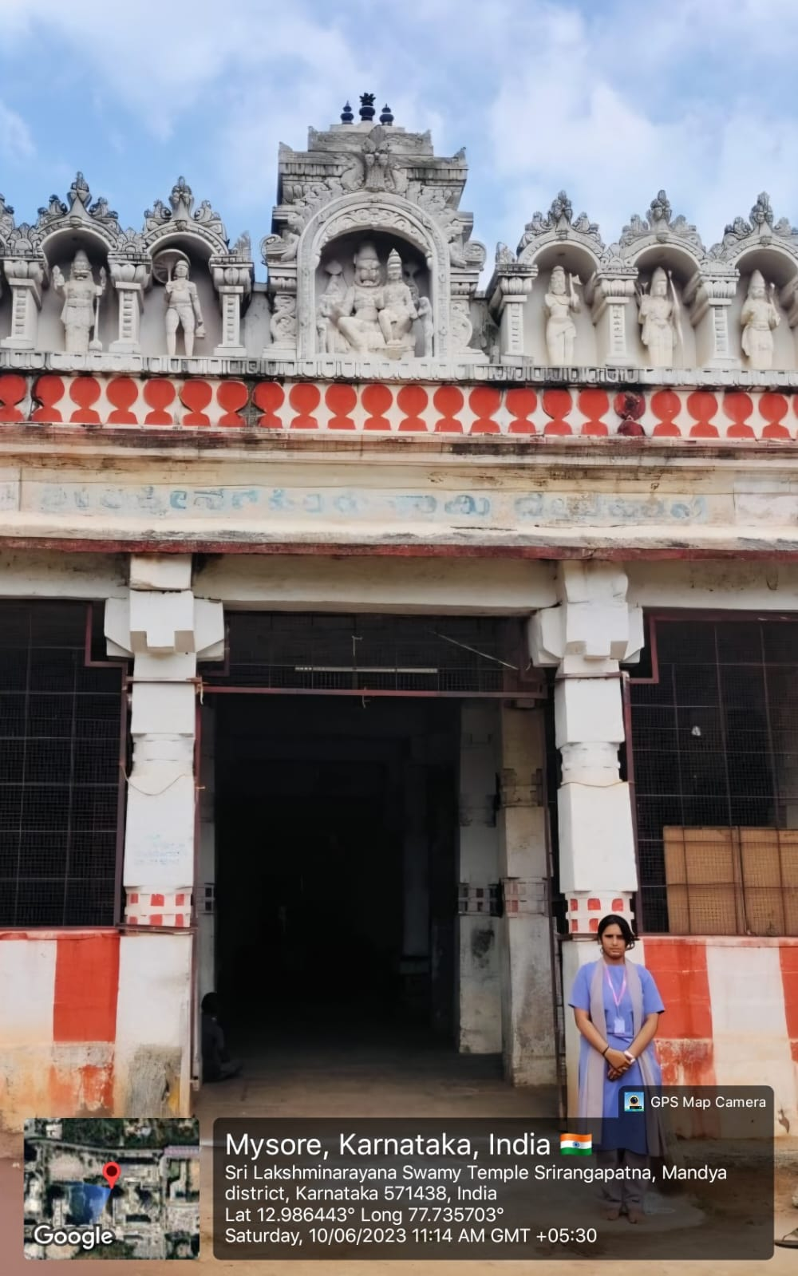
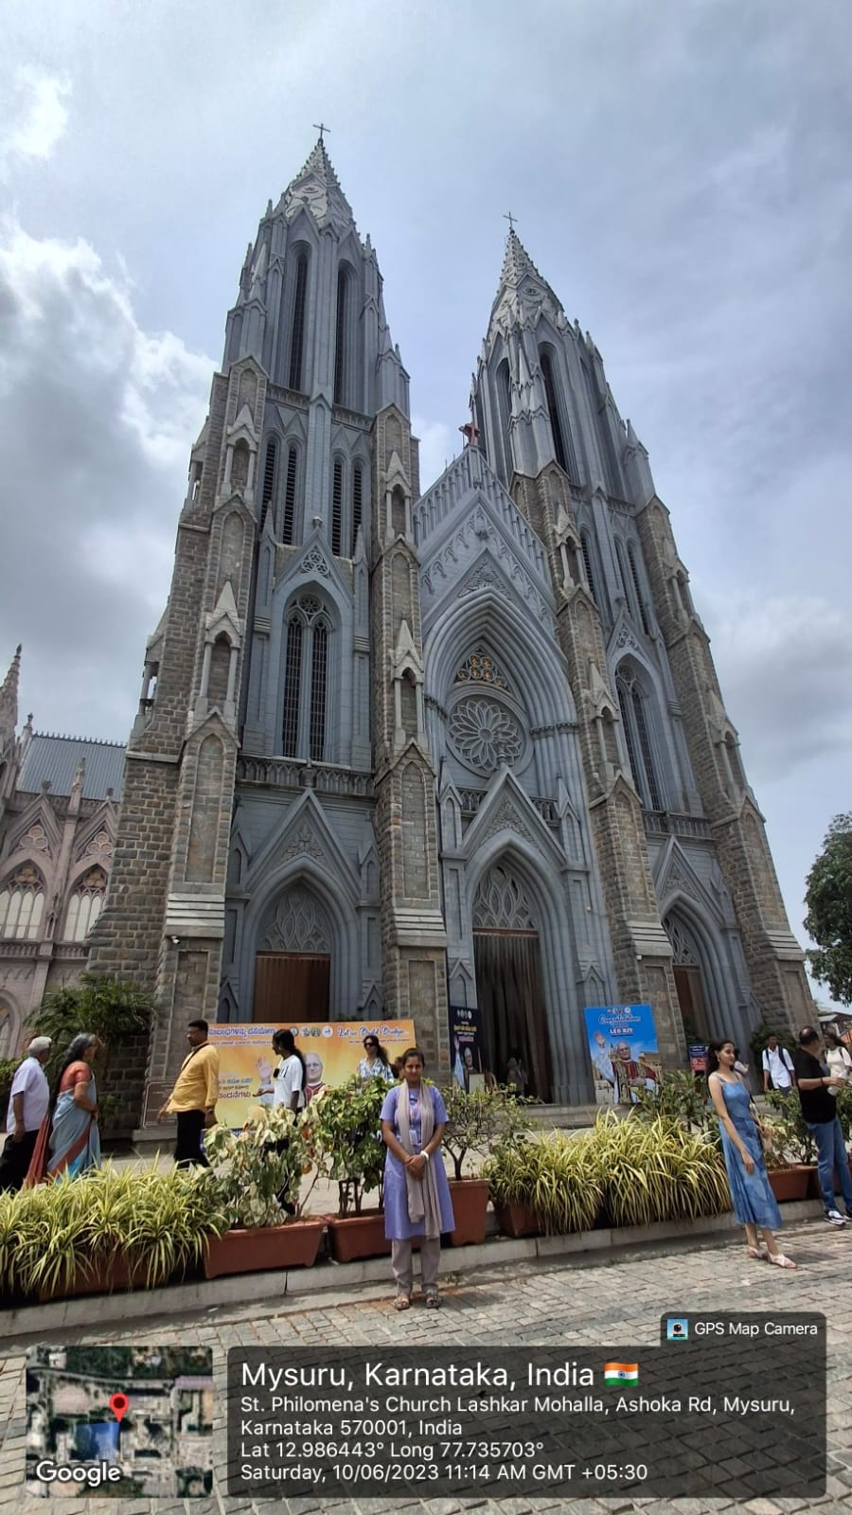

Figure 1.7 St. Philomena’s Church Figure 1.8 Sri Lakshminarayana Swamy Temple

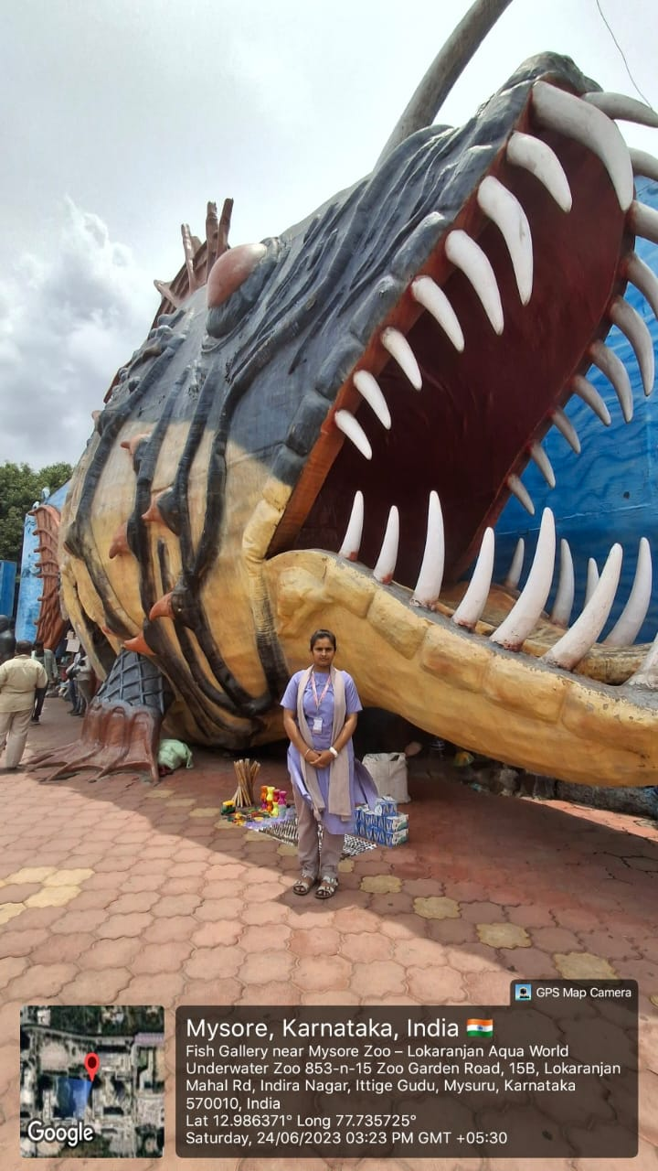
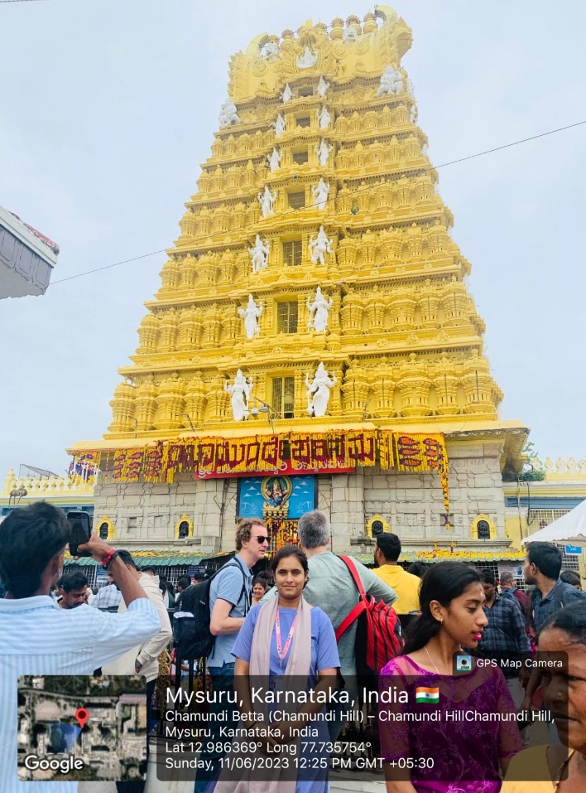

Figure 1.9 Chamundi Hill Figure 1.10 Lokaranjan Aqua World Underwater Zoo

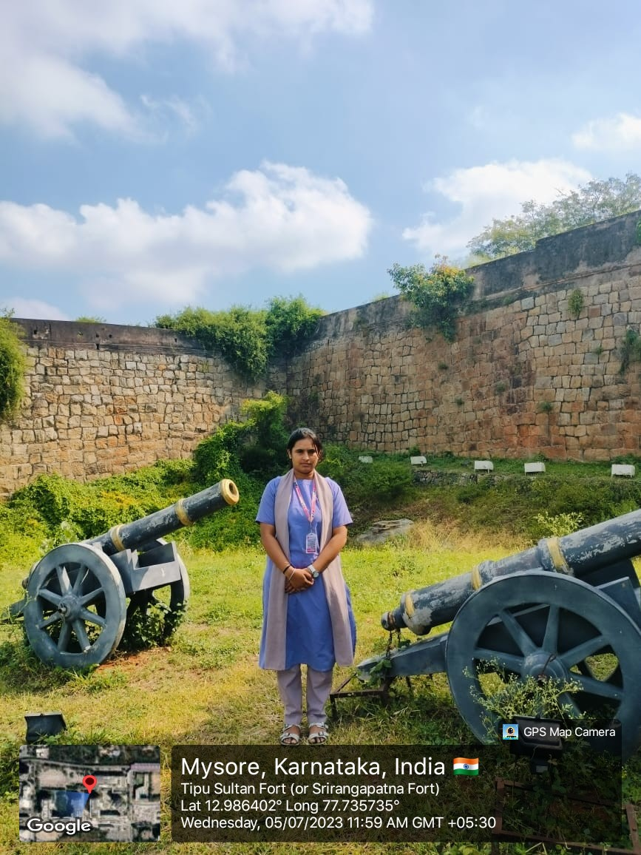
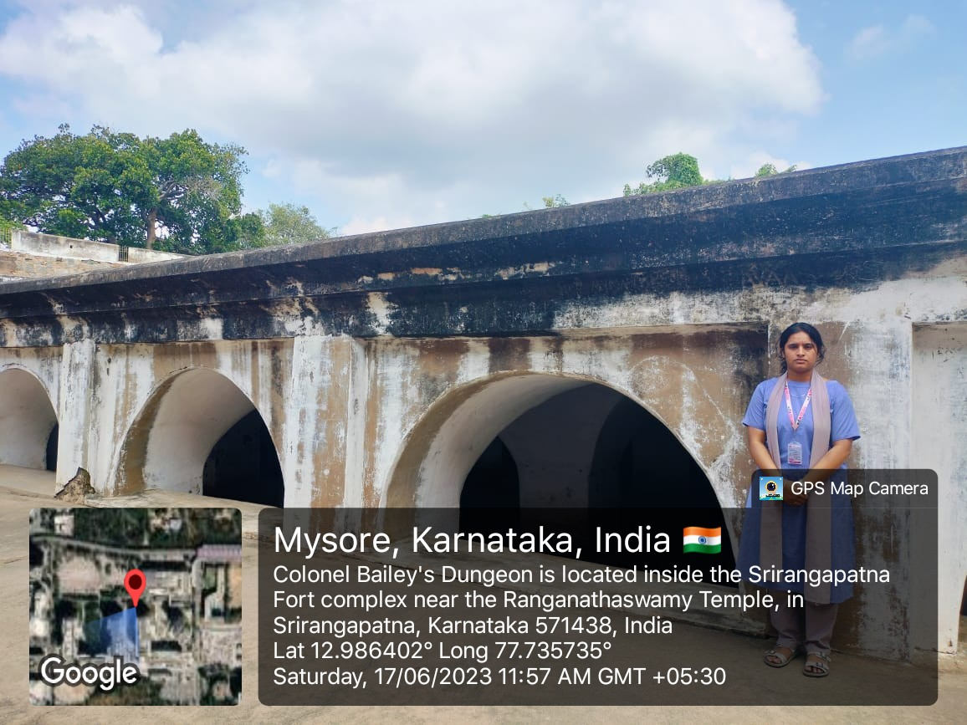

Figure 1.11 Colonel Bailey’s Dungeon Figure 1.12 Tipu Sultan Fort

Activity 2: Facilitating 100% Digitized Money Transactions
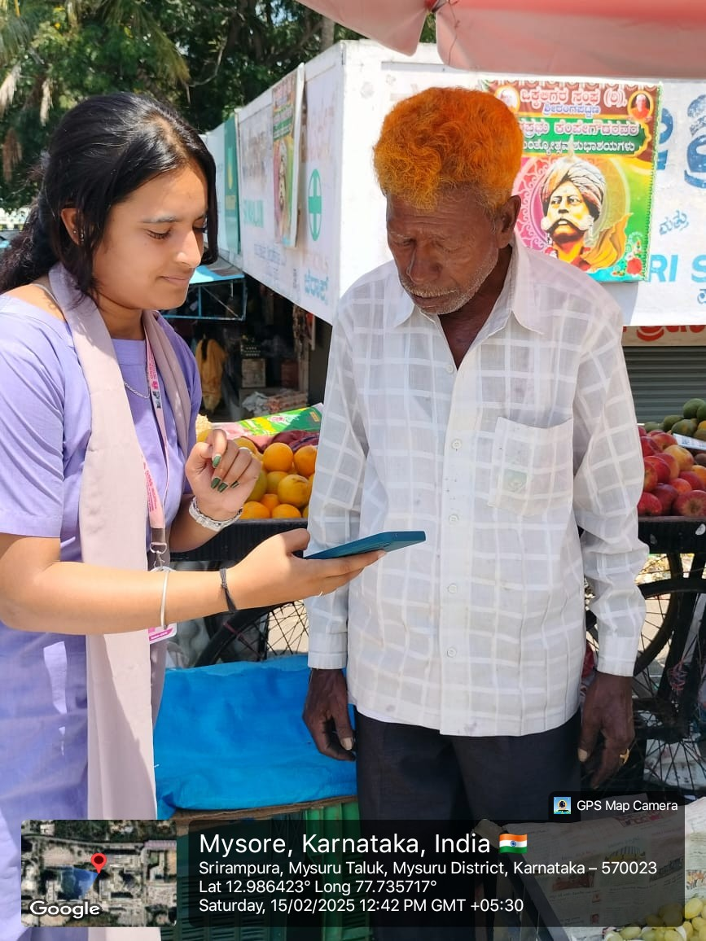
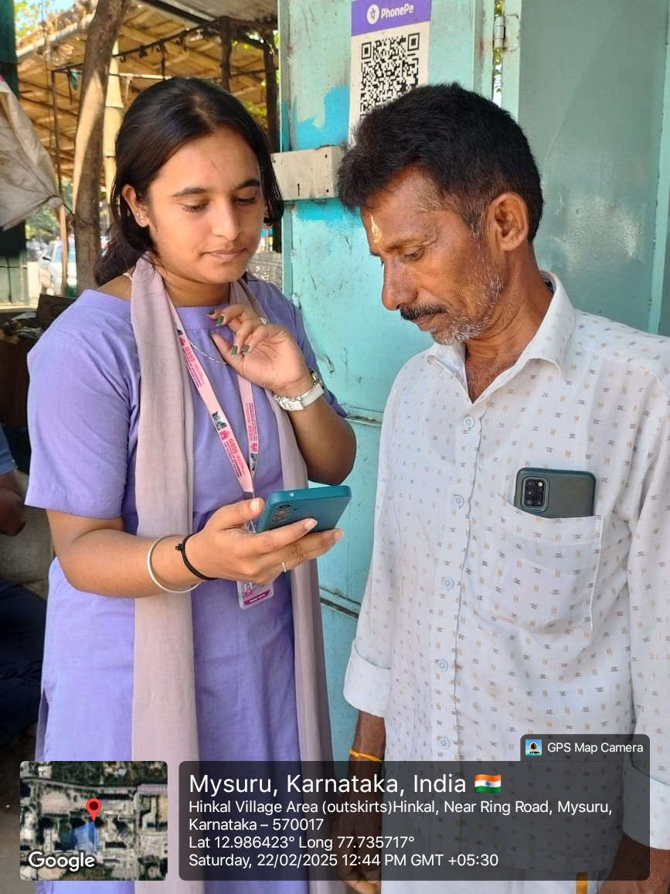

Figure 2.1 Promoting Digitized Transaction Figure 2.2 Promoting Digitized Transaction

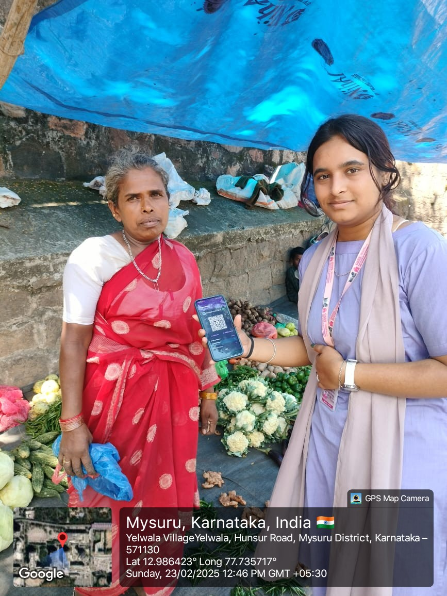
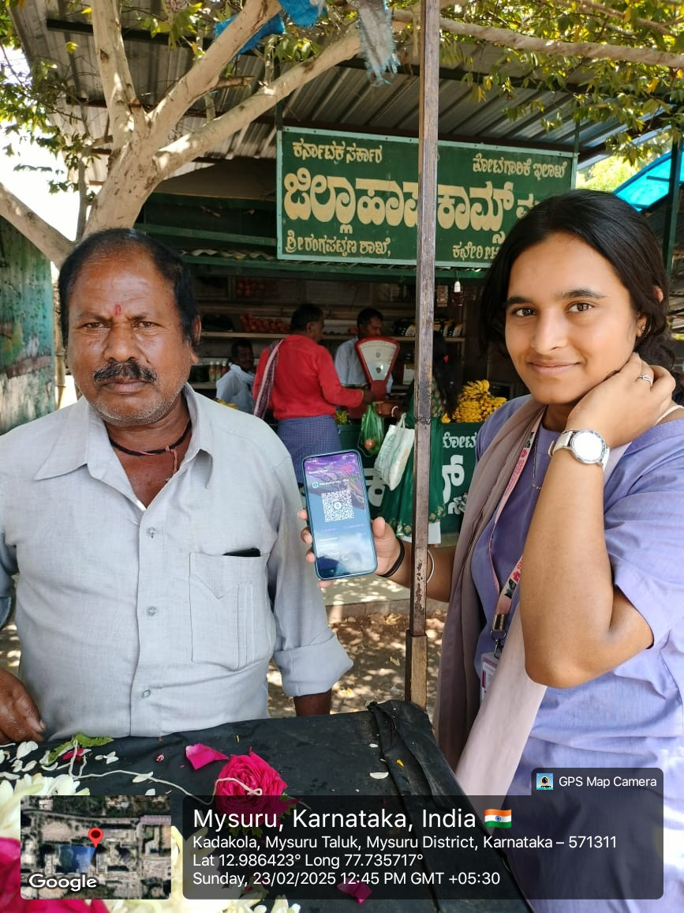

Figure 2.3 Promoting Digitized Transaction Figure 2.4 Promoting Digitized Transaction

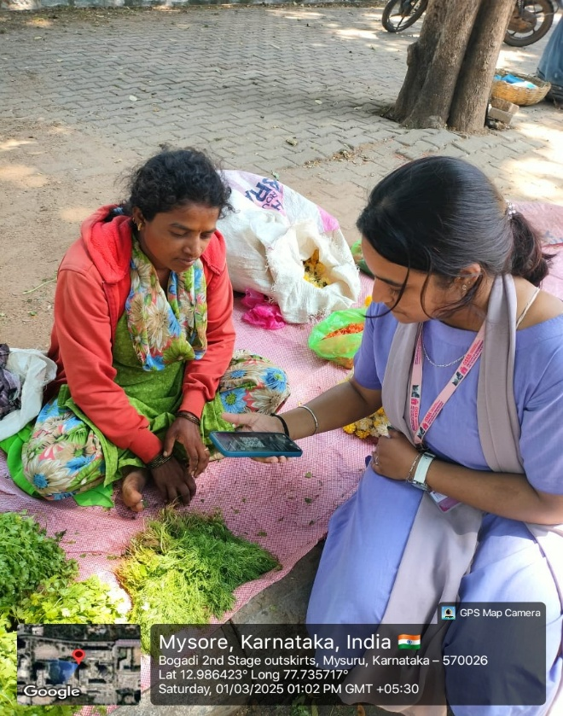
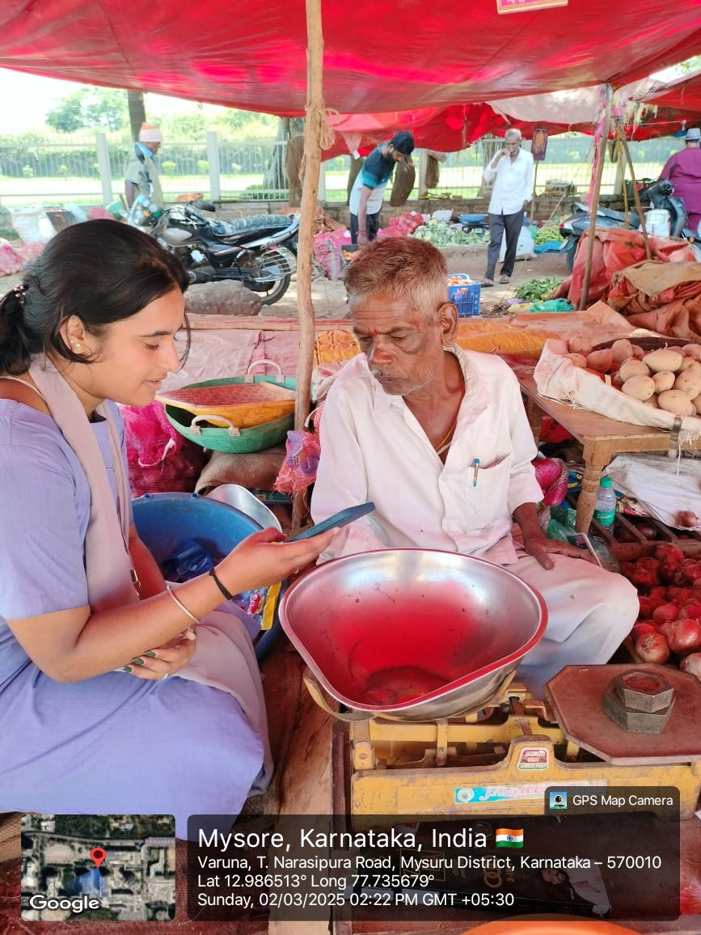

Figure 2.5 Promoting Digitized Transaction Figure 2.6 Promoting Digitized Transaction

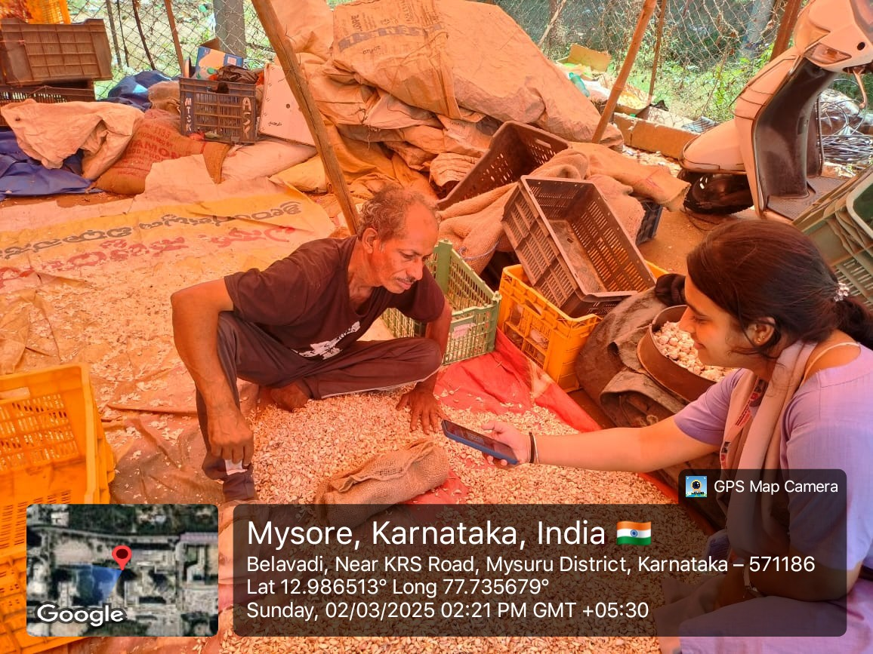

Figure 2.7 Promoting Digitized Transaction

Activity 3: Developing Sustainable Water Management System

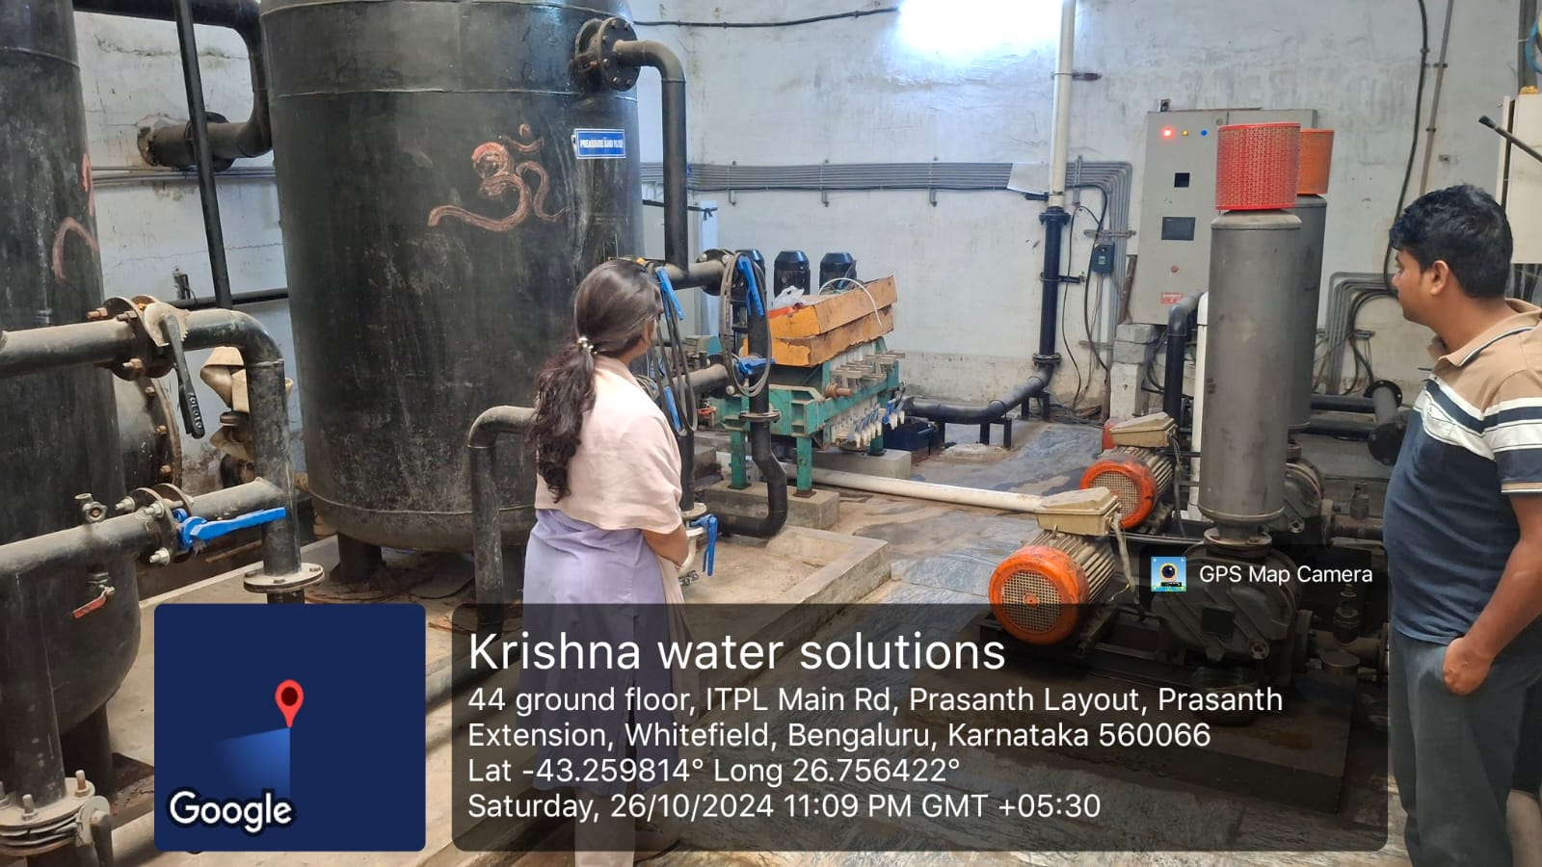

Figure 3.1 Observing wastewater treatment process

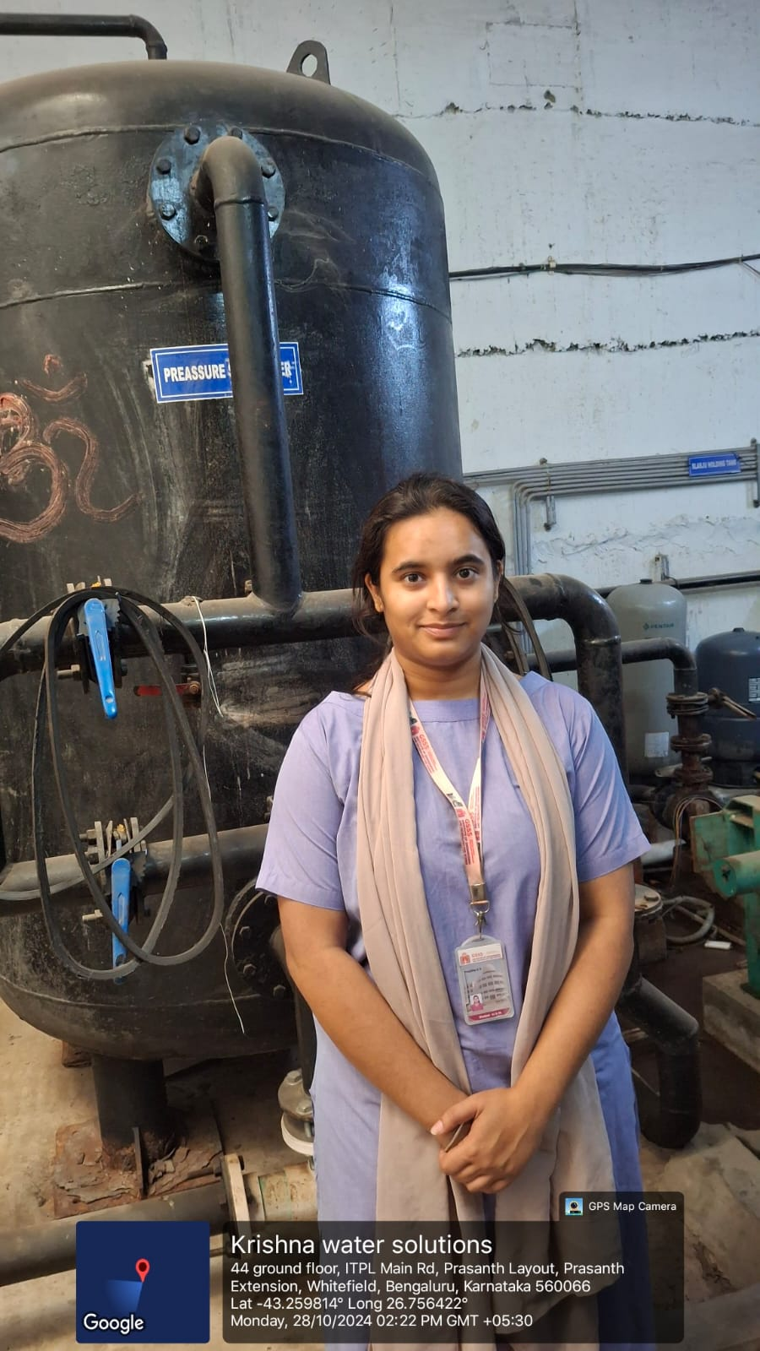
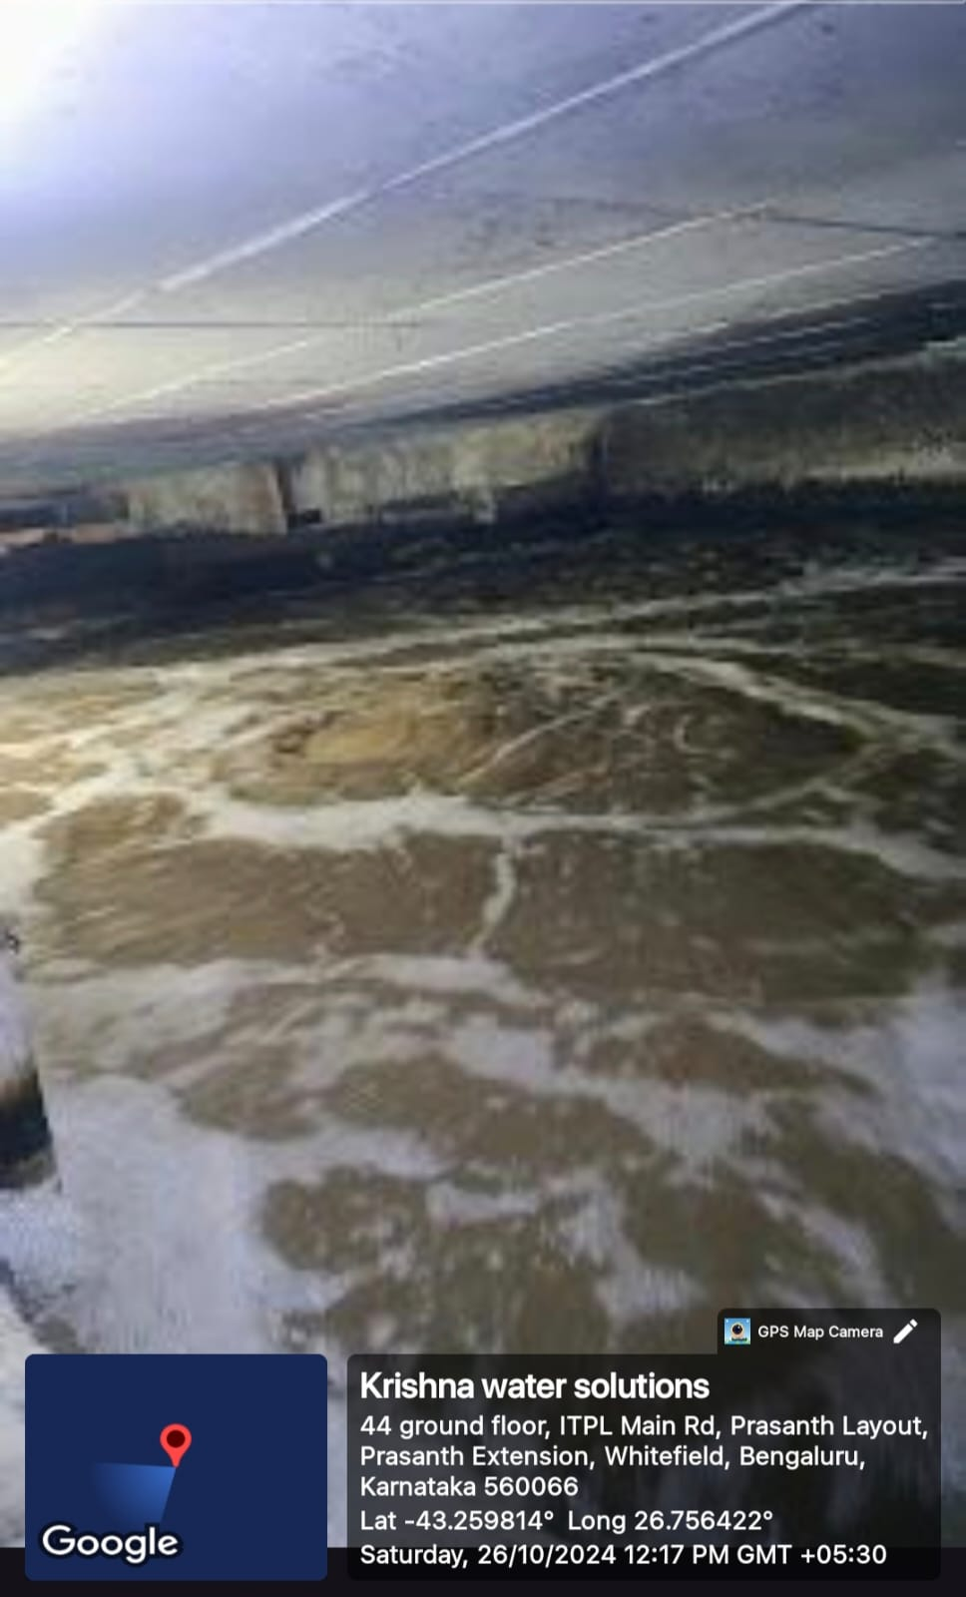

Figure 3.2 Exploring pressure sand filtration Figure 3.3 Understanding dual media filtration

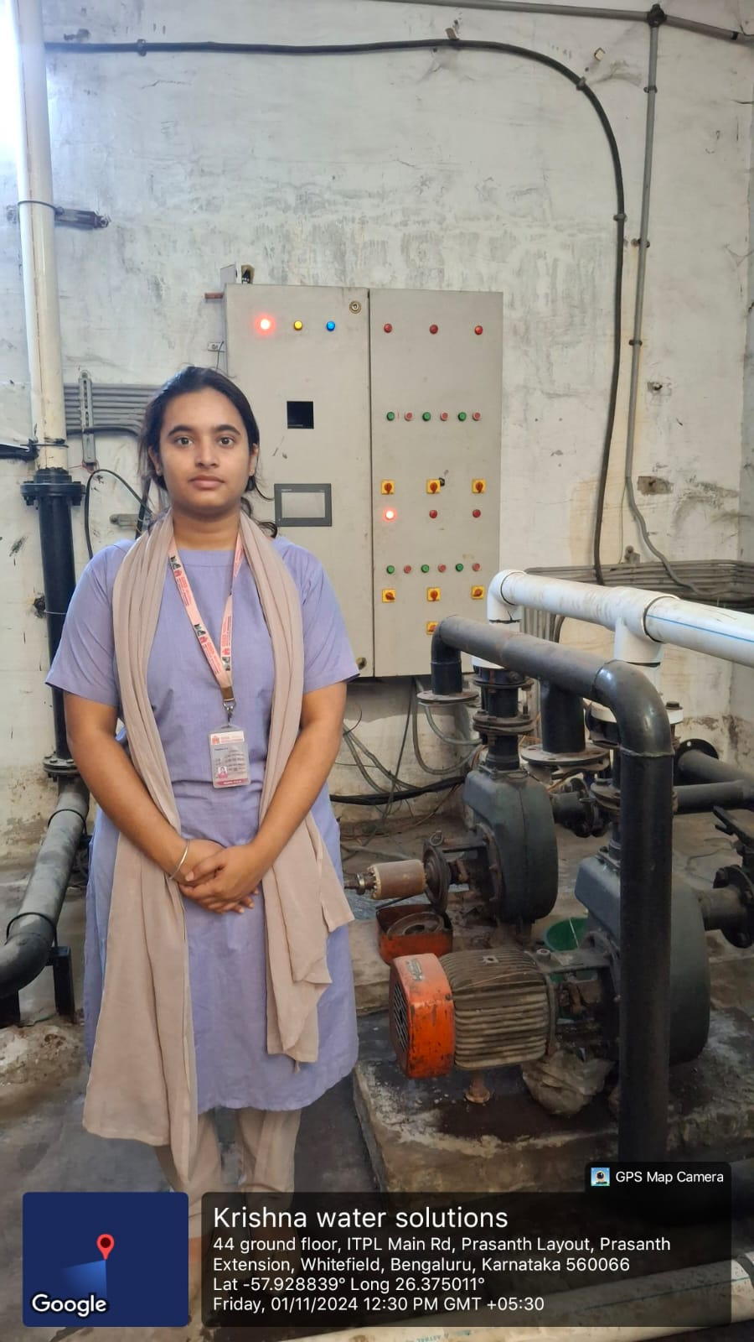
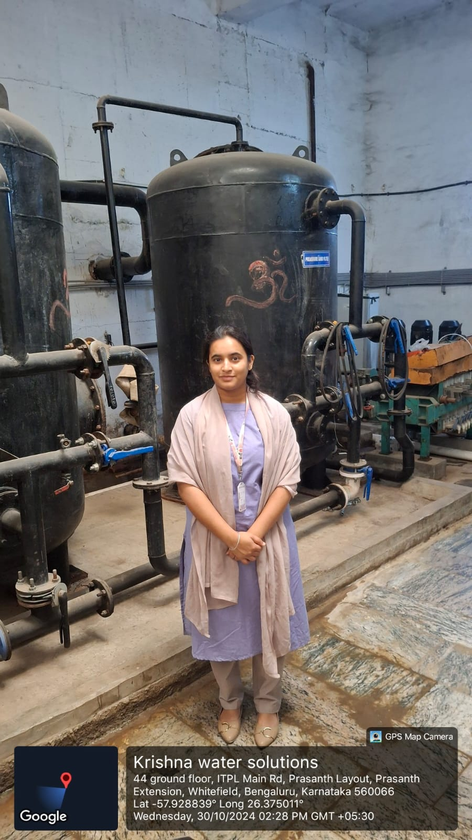
. Figure 3.4 Learning water purification stages Figure 3.5 Exploring pressure sand filtration
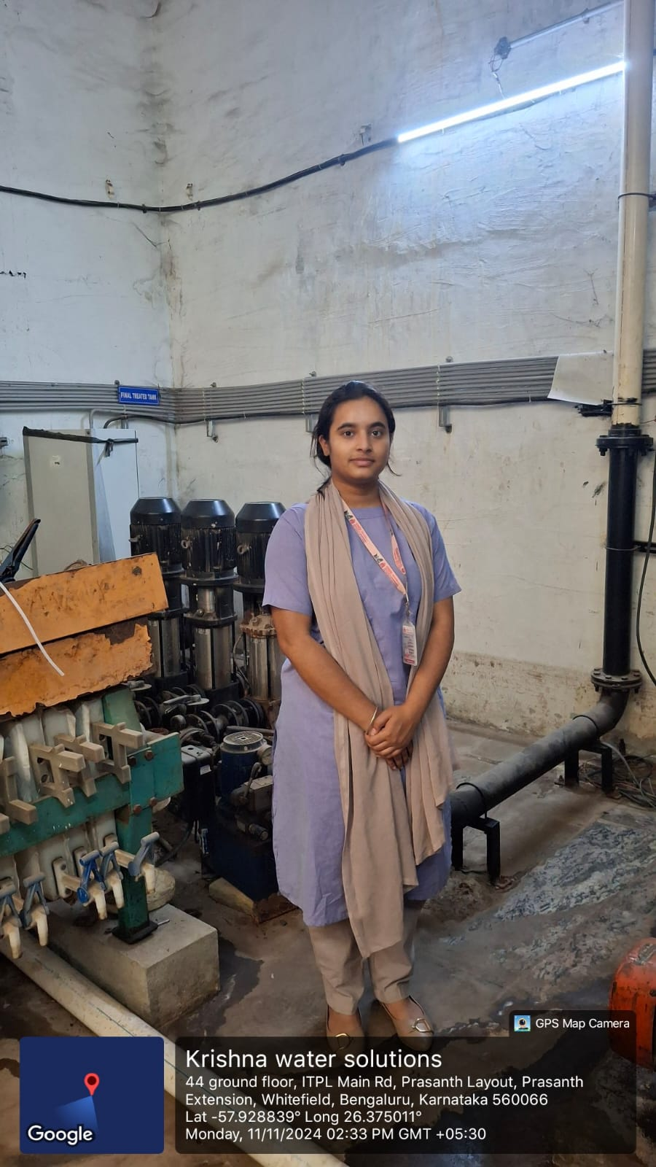
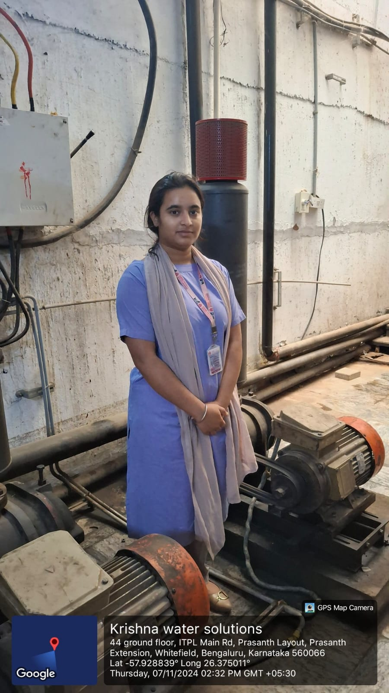

Figure 3.6 Observing wastewater treatment Figure 3.7 Examining flash mixer operation

Activity 4: Spreading Public Awareness under Rural Outreach Programmes
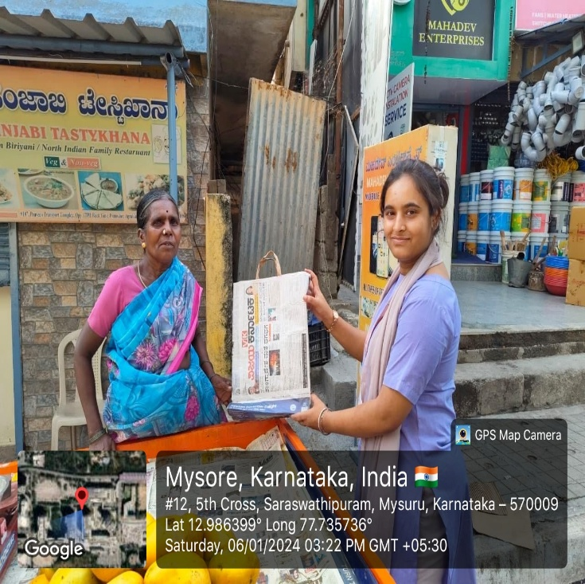 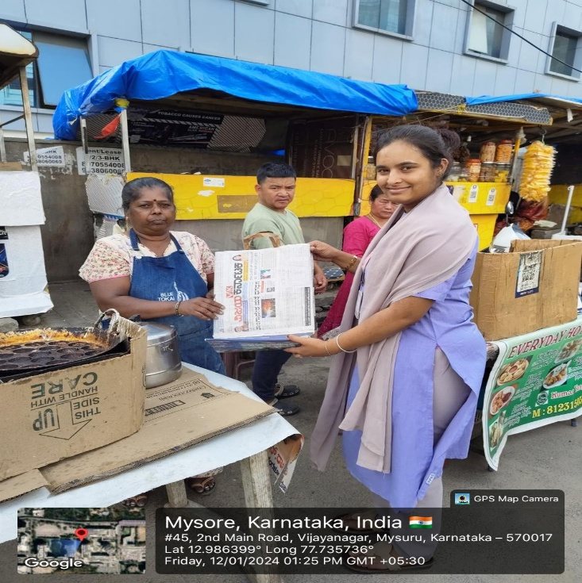 . Figure 4.1 Paper Bag Figure 4.2 Paper Bag
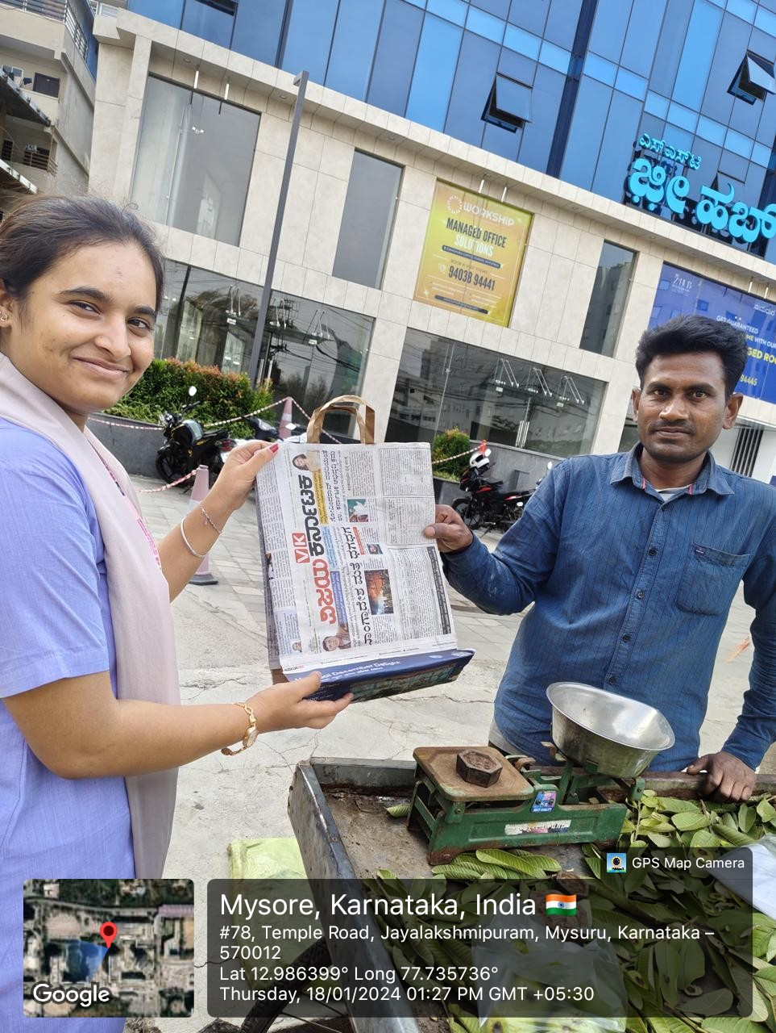

Figure 4.3 Paper Bag

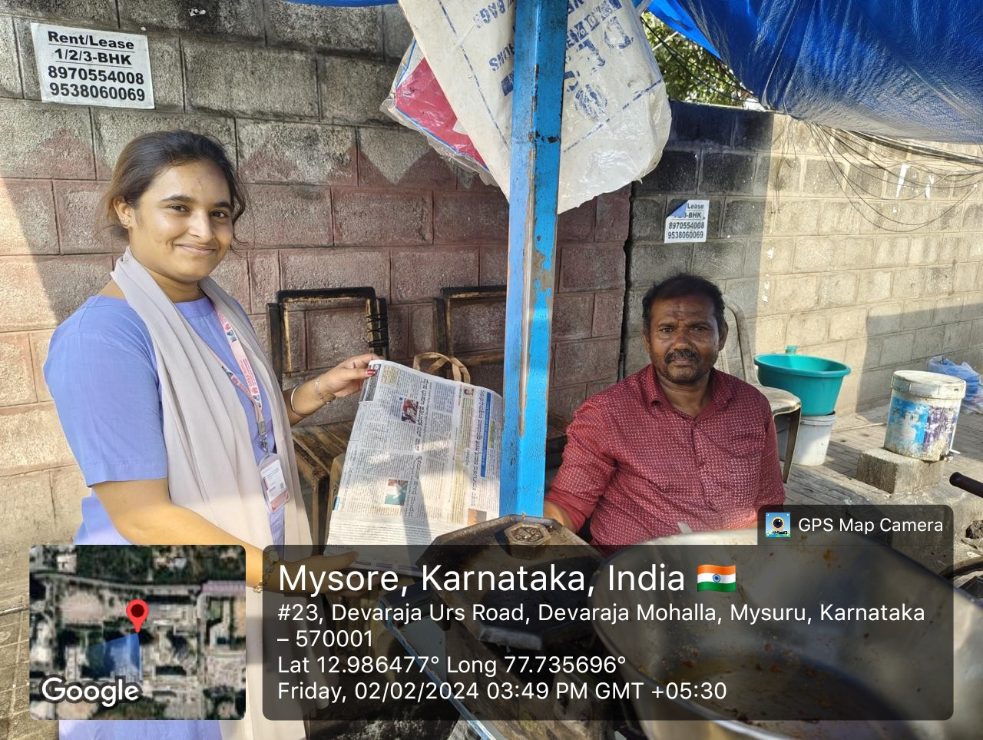

Figure 4.4 Paper Bag

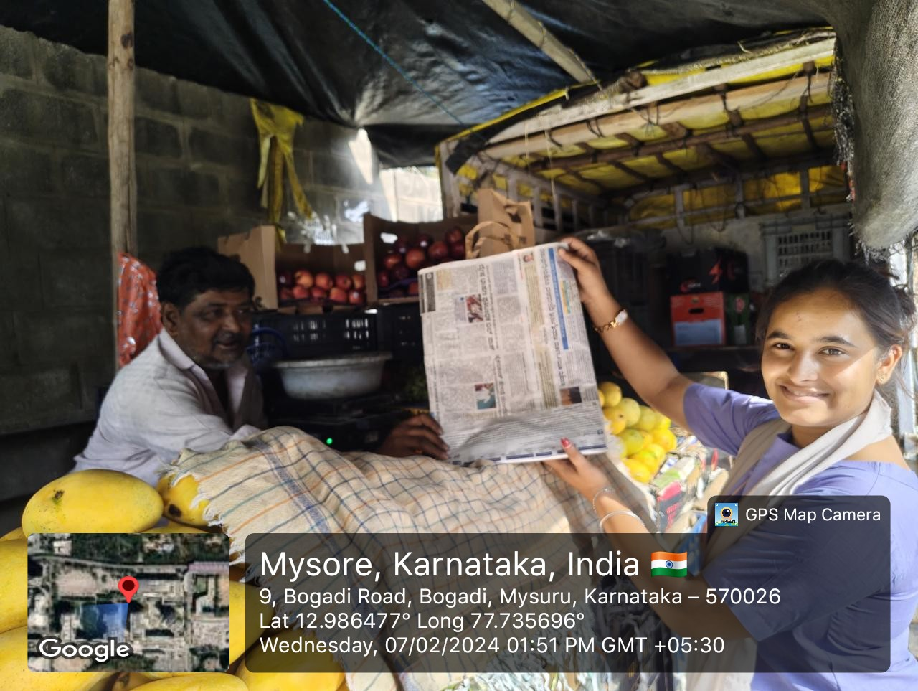

Figure 4.5 Paper Bag

Activity 5: Contribution to any national level initiative of Government of India.

Swachh Bharat Internship

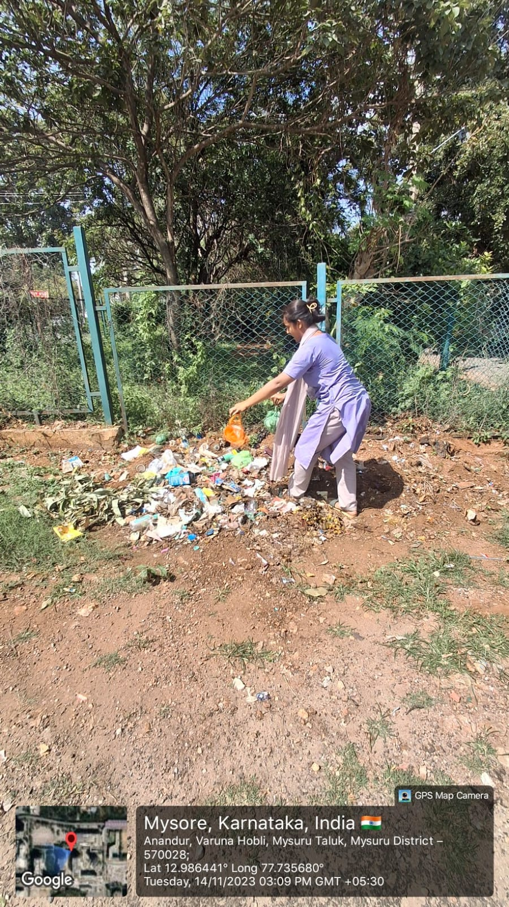

Figure 5.1 Swachh Bharat Internship

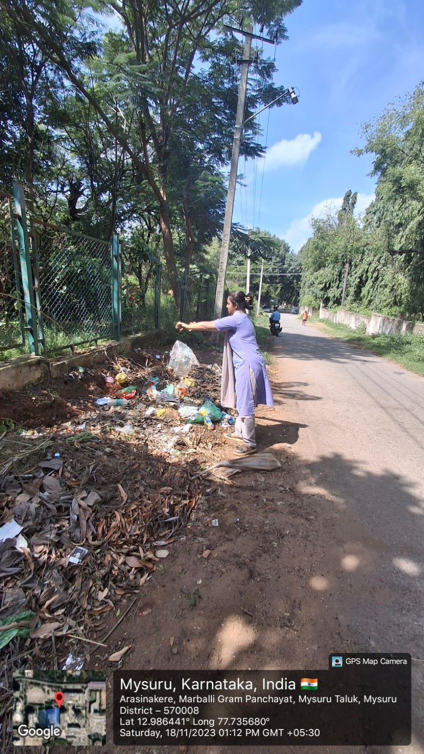

Figure 5.2 Swachh Bharat Internship

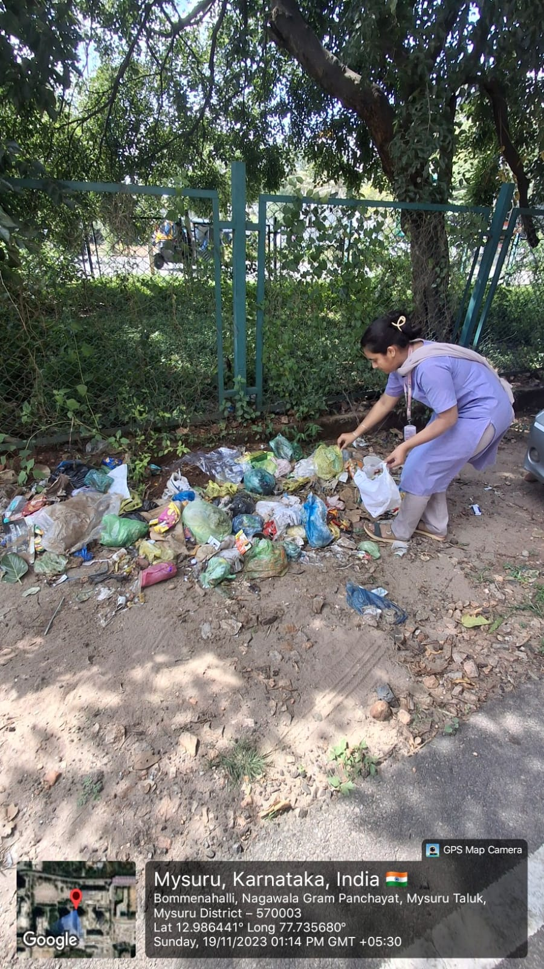

Figure 5.3 Swachh Bharat Internship

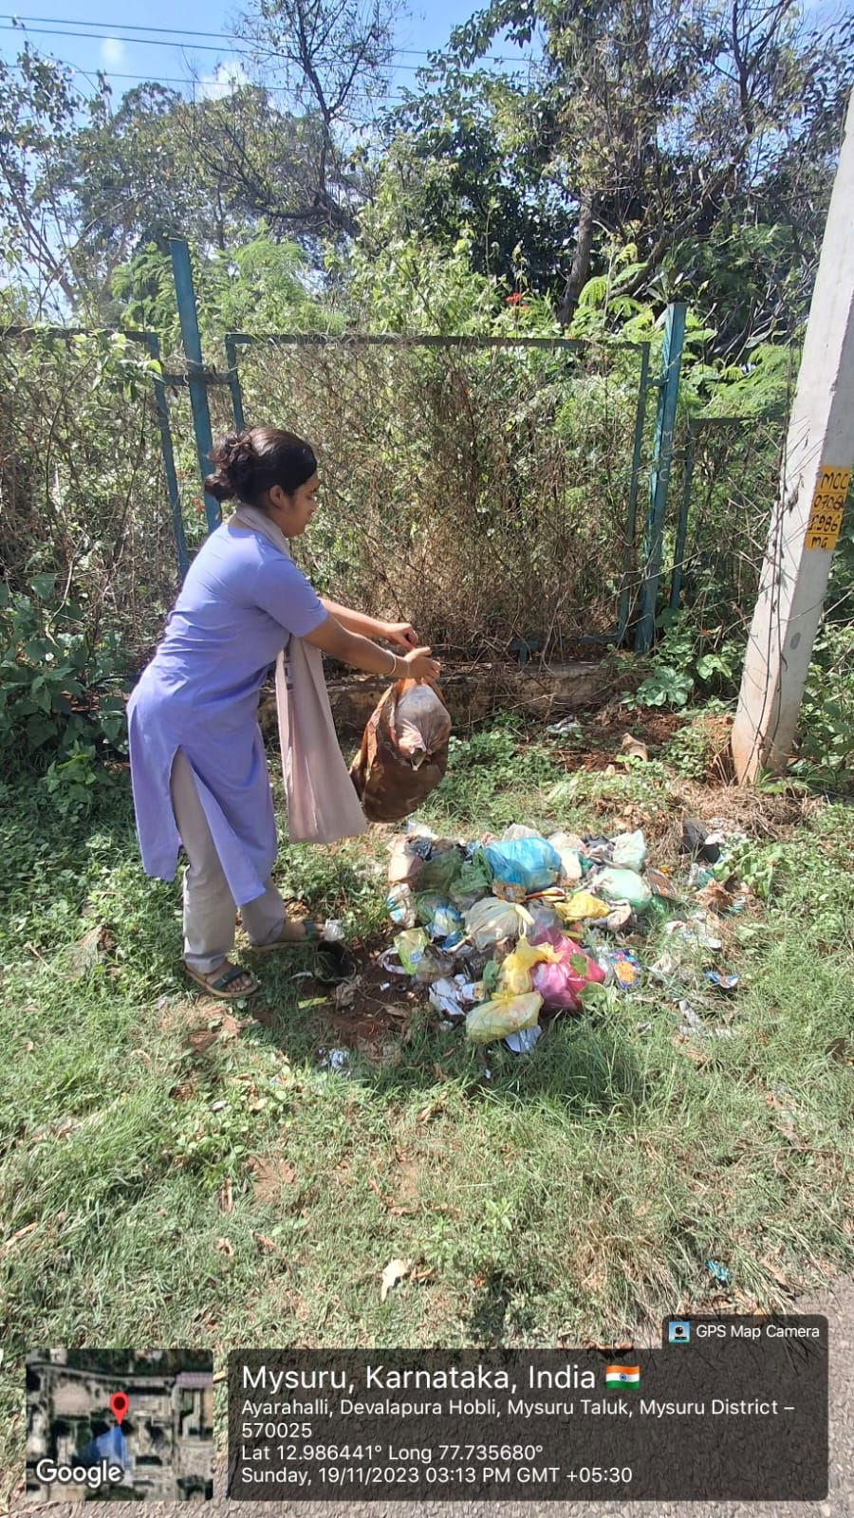

Figure 5.4 Swachh Bharat Internship

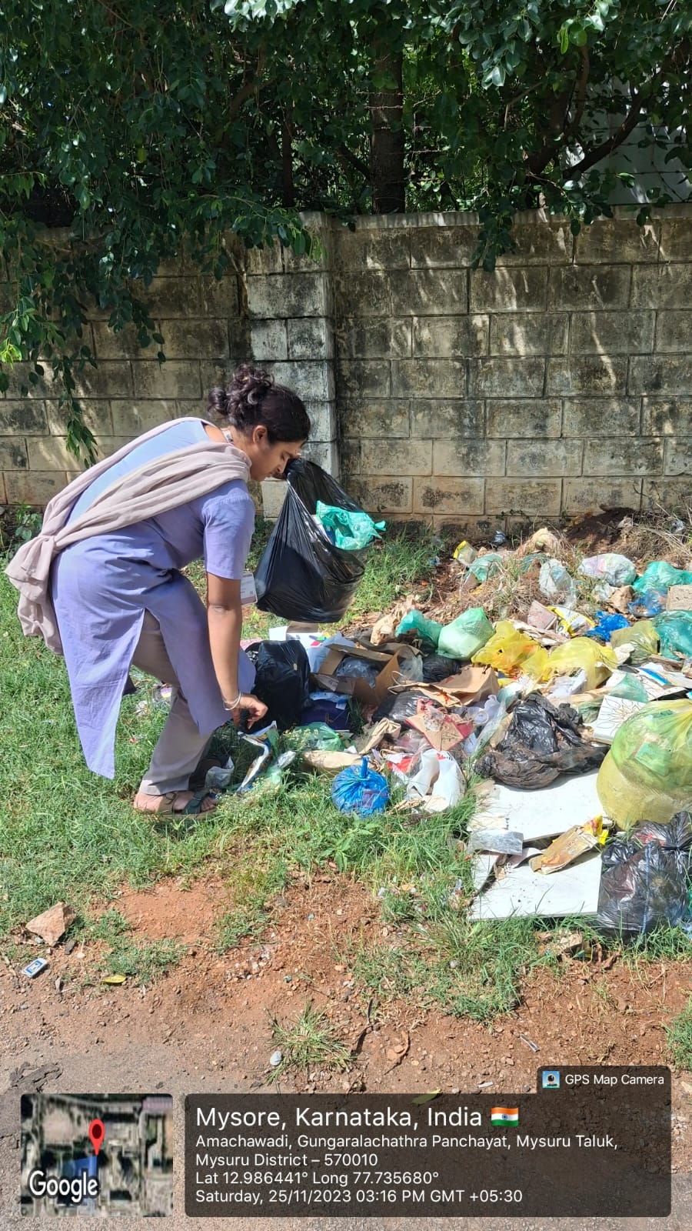
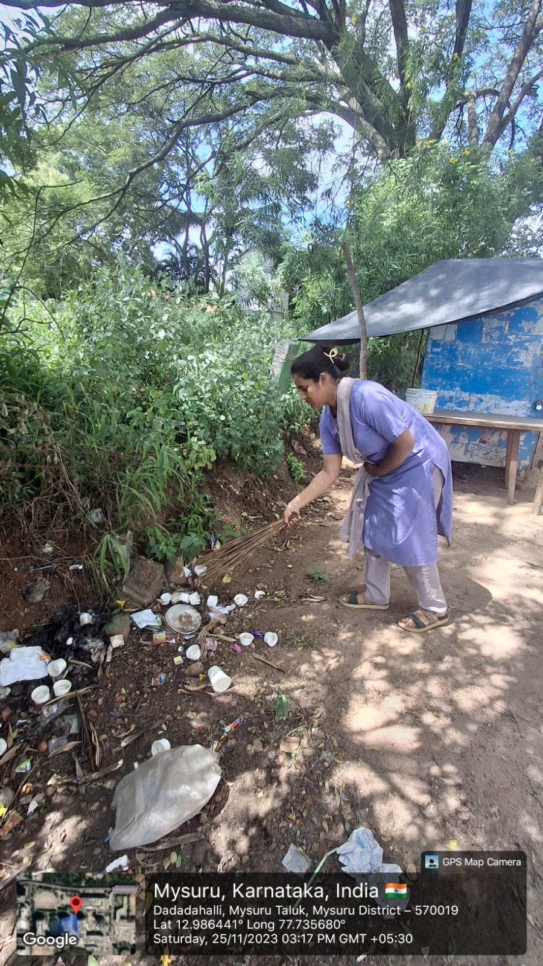

Figure 5.5 Swachh Bharat Internship

Figure 5.6 Swachh Bharat Internship

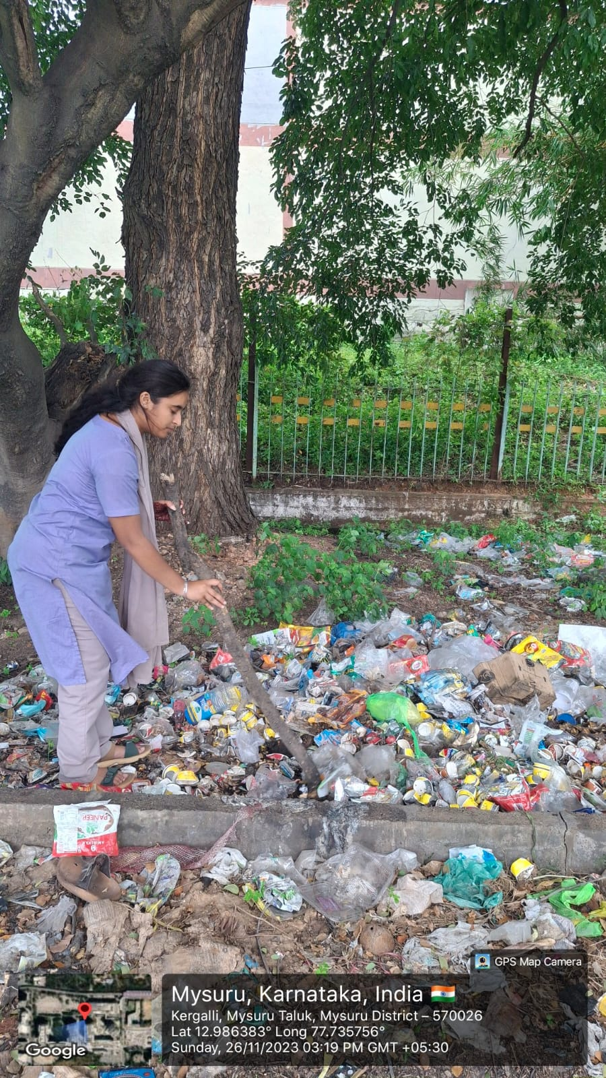

Figure 5.7 Swachh Bharat Internship

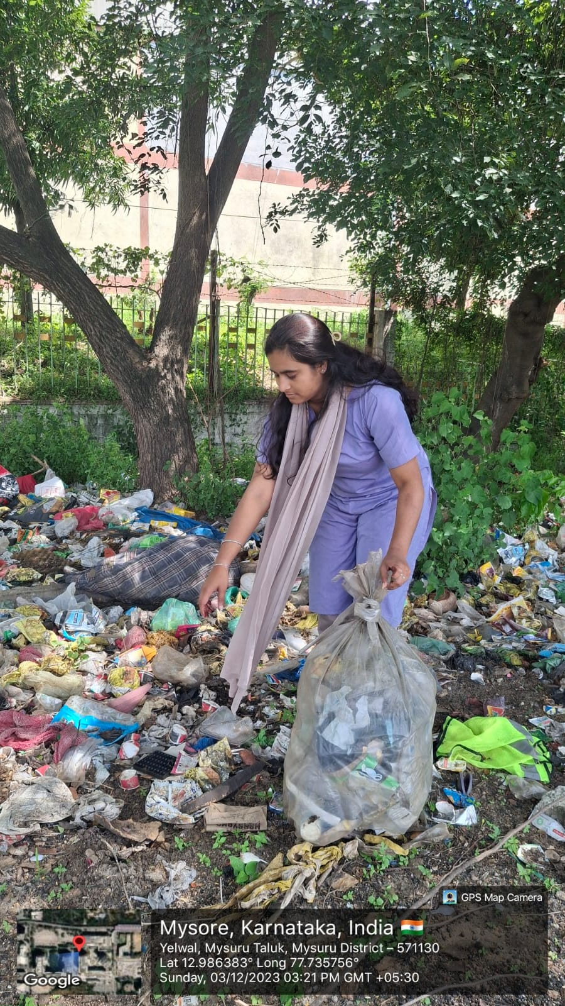

Figure 5.8 Swachh Bharat Internship

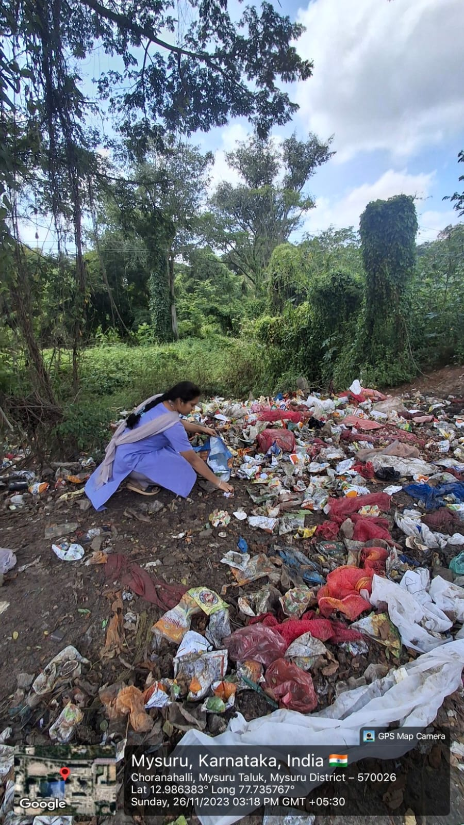

Figure 5.9 Swachh Bharat Internship

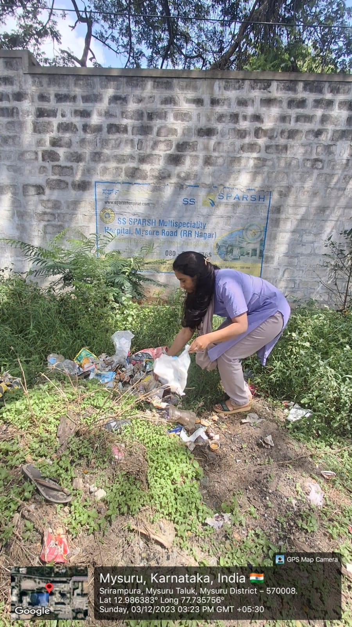

Figure 5.10 Swachh Bharat Internship

CHAPTER 5

CONCLUSION
The five AICTE activities which I completed created opportunities for me to develop practical skills which included social responsibility and digital awareness and environmental care and community interaction. The activities enabled me to use my classroom knowledge for practical applications while learning how important it is to give back to society.
The program taught me that digital payment promotion and cleanliness maintenance and local community support and awareness creation all result in positive results when these activities are performed consistently. My ability to communicate better developed through my experiences with different people because I needed to practice both communication skills and problem-solving skills.
The activities showed me how sustainability works and how people become aware of things and how technology gets used during their everyday activities. The program provided me with knowledge about community needs and motivated me to participate in activities which promote social development and responsible citizenship.

